

Identifying and Resolving MDX Query Performance Bottlenecks in SQL Server 2005 Analysis Services
SQL Server Best Practices Article

Writers: Carl Rabeler, Eric Jacobsen
Technical Reviewer: Craig Utley

Published: August 2007
Applies To: SQL Server 2005 Service Pack 2

Summary: To improve the performance of an individual MDX query that is performing poorly, you must first identify the source(s) of the performance bottlenecks in the execution of the query. This requires that you understand how to use Windows and SQL Server 2005 Analysis Services troubleshooting tools. This best practices article provides information about available troubleshooting tools and demonstrates how to use the most common of these tools to identify and resolve MDX query performance bottlenecks.

Copyright

The information contained in this document represents the current view of Microsoft Corporation on the issues discussed as of the date of publication. Because Microsoft must respond to changing market conditions, it should not be interpreted to be a commitment on the part of Microsoft, and Microsoft cannot guarantee the accuracy of any information presented after the date of publication.

This Article is for informational purposes only. MICROSOFT MAKES NO WARRANTIES, EXPRESS, IMPLIED OR STATUTORY, AS TO THE INFORMATION IN THIS DOCUMENT.

Complying with all applicable copyright laws is the responsibility of the user. Without limiting the rights under copyright, no part of this document may be reproduced, stored in or introduced into a retrieval system, or transmitted in any form or by any means (electronic, mechanical, photocopying, recording, or otherwise), or for any purpose, without the express written permission of Microsoft Corporation.

Microsoft may have patents, patent applications, trademarks, copyrights, or other intellectual property rights covering subject matter in this document. Except as expressly provided in any written license agreement from Microsoft, the furnishing of this document does not give you any license to these patents, trademarks, copyrights, or other intellectual property.

© 2007 Microsoft Corporation. All rights reserved.

Microsoft, Visual Basic, Visual Basic for Applications, Visual C#, Visual Studio, and Windows are either registered trademarks or trademarks of Microsoft Corporation in the United States and/or other countries.

The names of actual companies and products mentioned herein may be the trademarks of their respective owners.

Table of Contents
Introduction 1
Methodology for Identifying MDX Query Performance Bottlenecks 1
Query Execution Analysis Tools 3
SQL Server Profiler 3
System Monitor 7
MSAS 2005:MDX 7
MSAS 2005:Storage Engine Queries 9
Windows Task Manager 10
Kernrate and Kernrate Viewer 10
Process Monitor 11
MDX Script Performance Analyser 11
Analyzing Query Execution in Sample Queries 11
Getting Started with Query Execution Analysis 12
Cache Matching, Filtering, and Prefetching 12
Prefetching and Request Reordering 22
Storage Engine Bottlenecks and Solutions 25
Reducing Disk I/O 25
Manually Warming the Cache 25
Using Partitions and Aggregations 26
Using the Create Cache Statement or With Cache Clause 34
Formula Engine Bottlenecks and Solutions 39
Ranking Over Sets 40
Case, IIF, and Non_Empty_Behavior 44
Conclusion 54
Appendix A 55
Appendix B 56
Appendix C 57

Introduction
Identifying the source(s) of performance bottlenecks with an MDX query generally begins with determining whether the performance bottleneck is intermittent or reproducible. With reproducible performance bottleneck issues, you generally begin by figuring out where, within the SQL Server Analysis Services engine, the performance bottleneck is occurring. Once you understand the general area causing the bottleneck, you can begin to figure out how to improve the performance of an individual MDX query. Figuring out some performance bottlenecks is fairly straightforward while others may require you to dig deep to understand the reason for the performance bottleneck. Once you understand the cause of each performance bottleneck, you can begin to solve each identified cause.
This article describes the tools that you need to use to identify MDX query performance bottlenecks, and specifically focuses on the use of SQL Server Profiler to identify and solve MDX query performance bottlenecks. It uses a number of MDX queries that illustrate different types of performance bottlenecks, and explains how these bottlenecks reveal themselves within SQL Server Profiler and System Monitor.
Note Always use the most recent service pack (and, when appropriate, the most recent cumulative update package) when trying to resolve MDX query performance bottlenecks, as improvements are contained in each new service pack.

Methodology for Identifying MDX Query Performance Bottlenecks
Use the following steps to determine the source(s) of inadequate performance with an MDX query.
- Determine if a unique design or infrastructure scenario is involved that affects all MDX queries rather than an individual query. For example, query performance problems can be the result of a slow network, dimension or cell writeback, remote partitions, linked dimensions or measure groups across servers, or ROLAP storage. MDX query performance problems due to these causes are beyond the scope of this article. For more information about solving these types of performance issues, see the SQL Server 2005 Analysis Services Performance Guide and OLAP Design Best Practices for Analysis Services 2005.
- Determine if a poorly performing query always performs inadequately or if the performance issues with the MDX query are intermittent. The root cause for intermittent issues with MDX query performance is frequently one of the following:
- Concurrent queries competing for memory, processor, and I/O resources. Insufficient resources to handle the query load will cause intermittent query performance problems. Inadequate memory resource causes evictions from the data and calculation caches, which may require that subsequent queries be resolved from disk rather than cache, and may also resolve in memory paging. Inadequate processor resources cause thread contention and inadequate I/O resources cause disk queuing. Monitoring and resolving these issues is beyond the scope of this article. For more information about solving these types of performance issues, see the SQL Server 2005 Analysis Services Performance Guide.
- A locking condition caused by proactive caching or other processing operations. When a processing operation is ready to commit its changes to the object being processed, an exclusive lock must be obtained. If a long-running query prevents the exclusive lock from being obtained immediately, the lock request is queued and all subsequent MDX queries are queued behind the processing operation’s lock request. These queued queries will only execute after the lock request is successfully granted and the processing operation completes (or fails). By default, Analysis Services begins cancelling any such long running queries after five minutes (based on the ForceCommitTime server property) to allow the processing job to complete and minimize the blocking of subsequent MDX queries. Until the long-running query is cancelled, subsequent queries could be blocked for a long time. By default, the processing job’s lock request times out after 60 minutes (based on the ServerTimeout server property) if the long running-query cannot be cancelled before this time.
Note Cumulative Update Package 2 for SQL Server 2005 Service Pack 2 (SP2) contains a fix related to cancellation of long running queries. Obtain this fix if you are having issues with the cancellation of long running MDX queries.
- Measure group cache being cleared by proactive caching or other processing operations. When a partition processing operation commits, the data cache for the entire measure group containing the partition is cleared. Queries that execute immediately after the cache is cleared generally do not perform as well as queries that execute immediately before the cache is cleared.
- Determine whether the performance bottleneck is within the formula engine or the storage engine. To accomplish this, determine the amount of time required by the formula engine and the storage engine to execute the poorly performing MDX query when the cache is cold. The time spent by the storage engine can be determined by adding up the elapsed time for each Query Subcube event in a SQL Server Profiler trace. The time spent by the formula engine can be determined by subtracting the time spent by the storage engine from the total execution time for the Query End event.
- If a significant percentage (we use a guideline of approximately 30%) of the total time spent by Analysis Services resolving the poorly performing MDX query is spent in the storage engine, there is a storage engine bottleneck. Resolve storage engine bottlenecks by utilizing an appropriate partitioning strategy, defining a set of effective aggregations, eliminating excessive cache prefetching, and, in some cases, warming the cache. Examples of several queries that exhibit storage engine bottleneck behavior are illustrated in the examples later in this article, along with examples of each of the foregoing solutions.
- If a significant percentage (we use a guideline of approximately 30%) of the total time spent by Analysis Services resolving the MDX query is spent by the formula engine, there is a formula engine bottleneck. Resolve formula engine bottlenecks by writing MDX queries and calculations that utilize MDX language constructs that support block-oriented evaluation, eliminating empty tuples and cells before expensive calculations are executed, utilizing efficient Analysis Services stored procedures (stored procedures frequently have performance issues), and limiting, where possible, the use of unary operators, custom member formulas, non-native VBA functions, and indirect design methods (such as using StrToSet for dynamic evaluation of set members). Examples of several queries that exhibit formula engine bottleneck behavior are illustrated in the examples later in this article, along with several solutions.
Note If the total amount of time required to execute the poorly performing MDX query when the cache is warm is not substantially less than when the cache is cold, there is a formula engine bottleneck that you must spend time trying to resolve.
Important Appendices A and B contain diagrams that illustrate in a simplified manner the activities that occur within the formula and storage engine during query execution and help you understand where bottlenecks can occur. For more detailed information about how these components of Analysis Services resolves MDX queries, see Microsoft SQL Server Analysis Services by Edward Melomed, Irina Gorbach, Alexander Berger, and Py Bateman from SAMS Press.
Important Appendix B contains a compilation of the core MDX language constructs that support optimized block-oriented evaluation in SQL Server 2005 Service Pack 2.
Important Appendix C contains a list of Microsoft® Visual Basic® for Applications (VBA) functions that are natively implemented in SQL Server 2005 Analysis Services.

Query Execution Analysis Tools
Use the following tools to identify the source(s) of MDX query performance bottlenecks.

SQL Server Profiler
SQL Server Profiler is the primary tool to use to determine if a performance bottleneck is the formula engine or the storage engine and to understand storage engine bottlenecks. While SQL Server Profiler also provides some information regarding the steps taken by the formula engine to resolve a query, it provides little assistance in determining how to improve MDX query performance when the bottleneck is the formula engine. For this, you must use other tools (discussed later in this article).
The following SQL Server Profiler events are useful for conducting a query performance investigation and understanding the steps taken by the formula engine and the storage engine to resolve an MDX query.
Note The unit of resolution to the Duration column for these events is about 10 ms. For durations less than 10 ms (milliseconds), the time reported is 0 ms. A Windows clock tick is typically 16 ms. As a result, for an actual duration of greater than 0 and less than 32, the actual value reported in a trace could be 0, 16, or 32.
The events that follow are ordered, more or less, in the order in which they generally appear in a trace when the cache is cold.
- Command Begin and Command End
These events report the start and end of command execution events that could impact query performance and result in inconsistent query performance problems. The TextData column displays the text of each XMLA command. The Duration column for the Command End event displays the duration of the command and the CPU Time column displays the processor resources required.
In the context of troubleshooting MDX query performance issues, use this event to determine whether a CLEAR CACHE statement was issued before a particular MDX query or if a processing event is executing while your MDX query is executing.
- Query Begin and Query End
These events report the beginning and end of the MDX query. The Query Begin event means that the MDX query has been parsed and passed into the formula engine subsystem. The TextData column for these events reports the contents of the MDX query that is being evaluated. The Duration column for the Query End event reports the elapsed time for the execution of the entire MDX query and the CPU Time column reports the processor resources required.
After a Query Begin event and before the Query Cube Begin event (which marks the beginning of the execution of the SELECT statement) a number of events can occur. These events include the execution the MDX script and the resolution of scope (such as when a perspective is queried).
- Execute MDX Script Begin and Execute MDX Script End
These events report the execution of the MDX script. This script is stored in memory and is only executed after a CLEAR CACHE statement is executed or after a processing event that clears the cache.
During the execution of the MDX script, you may see a number of Query Dimension, Calculate Non Empty Begin, Calculate Non Empty Current, and Calculate Non Empty End events as the calculated members, named sets and assignments in the MDX script are evaluated. The exact events, of course, depend upon the calculations in the MDX script itself.
- Query Dimension
This event reports the reading of dimension data. The EventSubclass column for this event reports whether the dimension data was resolved from cache or from disk. The TextData reports the attributes in the dimension being queried (in a vector format of zeros and ones—more on interpreting this output is in the discussion of the Query Subcube and Query Subcube Verbose events) and the ObjectPath column (a non-default column) reports the dimension being queried.
- Calculate Non Empty Begin, Calculate Non Empty Current and Calculate Non Empty End
These events report NON EMPTY operations. For verbose information about NON EMPTY operations, use the Calculate Non Empty Current event.
The EventSubclass column for the Calculate Non Empty Current event reports the stages of each NON EMPTY operation (1 indicates the evaluating cell value step, 2 indicates the processing of calculated members step, and 3 indicates the reordering of tuples in the result set).
The Integer column for these events can report six different values. A value of 1, 2 or 3 indicates that the formula engine used a faster computation algorithm to perform the NON EMPTY operation. A value of 11, 12, or 13 indicates that the formula engine used a slower algorithm.
Note Using the Non_Empty_Behavior clause in a query, where appropriate, enables the Analysis Services engine to use a fast code path that is optimized for block-oriented computation. The use of this clause is discussed in Query 6 later in this article.

1 | All other NON EMPTY operations (using the faster algorithm). | This path will be executed for NON EMPTY, NonEmpty, and NonEmptyCrossJoin scenarios where the cells involved are either coming from storage engine data, or the calculations involved are determined to match some heuristics for performance – e.g. no complex recursion, no complex overlapping calculations.
2 | EXISTING operations (using the faster algorithm). | EXISTING operations are like Dimension Autoexist, except that they also take the current context into account (see the EXISTING keyword reference documentation for more information).
3 | AUTOEXISTS operations (using the faster algorithm). | AUTOEXISTS is a concept that describes how the Analysis Services engine trims empty rows from the cube space (see Autoexists in Books Online for more information). Calculate Non Empty events that show a 3 in the Integer column are reporting that dimension members are removed if the value is null.
11 | All other NON EMPTY operations (using the slower algorithm). | When the Analysis Services engine detects certain complex calculation conditions, it will forego the faster algorithm in favor of a slower algorithm that evaluates NON EMPTY operations for each cell.
12 | EXISTING operations (using the slower algorithm). | Theoretically possible, but should never occur in practice. EXISTING operations should always be able to follow the faster algorithm.
13 | AUTOEXISTS operations (using the slower algorithm). | Theoretically possible, but should never occur in practice. AUTOEXISTS operations should always be able to follow the faster algorithm.
The Duration column for the Calculate Non Empty End event reports the time in milliseconds required to perform the NON EMPTY operation and the CPU Time column reports the processor resources required.
The ProgressTotal column for the Calculate Non Empty Current event reports the number of cells being evaluated.
- Query Cube Begin and Query Cube End
These events report the beginning and end of the SELECT statement. The Duration column for the Query Cube End event reports the elapsed time for the execution of the SELECT statement portion of the MDX query, including all subcube queries to the storage engine utilized to resolve the MDX query. The CPU Time column reports the processor resources required.
- Serialize Results Begin, Serialize Results Current, and Serialize Results End
These events report the status of serializing axes and cells. When the Serialize Results End event fires, all axes and cells have been resolved and the result is returned to the client application. The EventSubclass and the TextData columns for the Serialize Results Current event track the axis (0, 1, or slicer) or cells being populated with data. The Duration column for the Serialize Results End event displays the time in milliseconds required to serialize results for the entire SELECT statement and the CPU Time column reports the processor resources required. The ProgressTotal column for the Serialize Results Current event reports the number of rows on each axis and the number of cells that are serialized. For large cell volumes, the ProgressTotal column for the Serialize Results Current event reports partial counts (every 1,000 cells).
- Get Data From Aggregation
This event reports the reading of data from an aggregation by the storage engine in response to a formula engine request for measure group data. The TextData reports the aggregation name and the attributes in each dimension being queried (in a vector format of zeros and ones—more on interpreting this output is in the discussion of the Query Subcube and Query Subcube Verbose events later in this list of events) and the ObjectPath column (a non-default column) reports the partition being queried.
Note The Get Data From Aggregation event currently reports twice when a distinct count partition is being read (even though it is only read once).
- Progress Report Begin and Progress Report End
These events report the reading of data from a measure group partition by the storage engine in response to a formula engine request for measure group data. Multiple Progress Report Begin events can fire simultaneously if data can be retrieved simultaneously from multiple partitions (although the formula engine can only consume retrieved data using a single thread—see the Query Subcube and Query Subcube Verbose events). A pair of these events fire for each partition being read. If the data is resolved from an aggregation rather than from the fact level, a Get Data From Aggregation event fires before these events fire. Neither of these events fire if the formula engine request is resolved from cache data. In this event, a Get Data From Cache event fires.
Note The Progress Report Begin and Progress Report End events do not fire when a distinct count partition is being read.
The TextData column reports information on which partition or aggregation was read. The Duration column for the Progress Report End event reports the elapsed time for the partition read and the CPU Time column reports the processor resources required. Query performance generally improves when the TextData column reports that an aggregation rather than data from the fact level is being read. When the Query Subcube or Query Subcube Verbose events indicate that a query is resolved from cache data, the Progress Report Begin and Progress Report End events will not appear for the trace.
Important In the rare case when too many aggregations (in the hundreds or thousands) have been defined, query performance may actually decrease when a query is resolved from cache.
Tip When defining custom aggregations, the descriptive names that you use for each aggregation in an aggregation design appear in the TextData column. Descriptive names, such as “aggregation for query 3,” are much more useful than a name such as “Aggregation 0.” You can provide descriptive names for each new or existing aggregation by using Aggregation Manager.
- Get Data from Cache
This event reports the reading of data from dimension cache and measure group cache in the cache system, rather than from a partition by the storage engine. The TextData column for this event reports the subcube query if the data was retrieved from the measure group cache and the cache scope if the data was retrieved from the calculation cache.
- Query Subcube and Query Subcube Verbose
These events report the subcube retrieved by the formula engine from the storage engine. The TextData column for these events reports the dataset requested. The TextData column for the QuerySubcube event reports the dataset in dimension vectors separated by commas and combined into a subcube vector (such as 000,000,011101,10). Within each dimension vector, a 0 for an attribute indicates that the value for the default member (generally the All level) is requested. A 1 for an attribute indicates that the value for some member(s) other than the default member is requested.
Note The subcube vector is the value that is recorded in the query log. This subcube vector can also be copied and pasted into the Aggregation Definition column in the SP2 Aggregation Manager utility (available on CodePlex at http://www.codeplex.com/MSFTASProdSamples ; a community-enhanced version of this utility is available on CodePlex at http://www.codeplex.com/bidshelper).
The TextData column for the QuerySubcubeVerbose event reports the dataset in human readable form, and contains additional information about the attribute member(s) requested.
- A 0 indicates that the value for the default member (generally the All level) is requested.
- An * indicates that values for all members of an attribute are requested, rather than a slice of one or more members.
- A non-zero number indicates that a single attribute is requested for the slice, with the number representing the data ID of the member requested.
- A + indicates that a slice on more than one member of a set is requested (the members of the slice are not displayed in the trace).
- A – indicates that a slice below granularity is requested (the members of the slice are not displayed in the trace). Below granularity means that the subcube being returned is filtered on a set that is not included in the subquery. This occurs when a set is included in a WHERE clause, when dimension security is involved, and a number of other scenarios.
The EventSubclass column for these events report whether cache (1 or 21) or non-cache data (2 or 22) is used to resolve the subcube request (from memory or from disk). The Duration column for these events reports the time in milliseconds required to perform the subcube request operation (the consumption of each Query Subcube event is single threaded) and the CPU Time column reports the processor resources required.
Tip If you determine that the source of a MDX query performance bottleneck is an Analysis Services stored procedure, you can use the Context.TraceEvent method to inject a user defined event into the SQL Server Profiler trace and provide custom event subclass, integer, and string data. For example, if your stored procedure has multiple loops, you can use this method to find out how much time is spent in each loop. For more information, see Best practices for server ADOMD.NET stored procedures.

System Monitor
System Monitor helps you confirm that the formula engine is a performance bottleneck (after making your initial determination by using SQL Server Profiler or Task Manager). System Monitor also provides some additional information about the steps taken by the formula engine to resolve a query, but this information provides little assistance in determining how to improve MDX query performance when the bottleneck is the formula engine.
The following System Monitor counters provide some information about the steps taken by the formula engine and the storage engine to resolve an MDX query and may provide some insight into MDX query performance issues.
Note The values for System Monitor counters are the accumulated value for the counter since the Analysis Services service started.

MSAS 2005:MDX
The counters under this object report the activities of the formula engine during execution of an MDX query.
- Total autoexist
This counter reports the total number of times that autoexist is performed.
- Total calculation cache registered
This counter reports the total number of calculation caches registered. A calculation cache is registered for each calculated member resolved in a query.
- Total Calculation covers
This counter reports the total number of calculation covers generated by the query execution engine. A calculation cover is a subcube for which a common set of calculations can be applied. An MDX query may cover a large subcube, with a wide range of calculations applying to different areas of the subcube. As a result, the formula engine may require that many calculation covers be generated in order to properly compute all of the calculations that are required by the MDX query.
A high value for this counter for a single query indicates that the formula engine resolved cell values for the query on a cell-by-cell basis rather than performing block-oriented evaluation.
- Total cells calculated
This counter reports the total number of cells calculated. A high value for this counter for a single query indicates that the formula engine resolved cell values for the query on a cell-by-cell basis rather than performing block-oriented evaluation.
- Total EXISTING
This counter reports the total number of times the EXISTING set operator executed.
- Total Flat Cache Inserts
This counter reports the total number of cell values inserted into the flat calculation cache. Formula engine caches use either flat space or subcubes to store data and calculations during query execution. A high value for this counter indicates that cell-by-cell evaluation was used to calculate cell values and that these cell values were inserted into the flat cache on a cell-by-cell basis.
- Total NON EMPTY
This counter reports the total number of NON EMPTY operations performed. To determine the total number of fast NON EMPTY operations for a given MDX query, subtract the values for Total NON EMPTY unoptimized and Total NON EMPTY for calculated members from the value for this counter.
- Total NON EMPTY for calculated members
This counter reports the total number of times the NON EMPTY algorithm is looping over calculated members. The slow NON EMPTY code path is used for calculated members, while a fast code path is used for members that are not calculated.
- Total NON EMPTY unoptimized
This counter reports the total number of times the unoptimized NON EMPTY algorithm is used. A high value for this counter indicates that the slow NON EMPTY code path is used to evaluate nonempty cells on a cell-by-cell basis.
- Total recomputes
This counter reports the total number of cells recomputed due to cell errors in an MDX expression or calculation, or from recursion errors.
- Total Sonar subcube
This counter reports the total number of subcubes generated by the formula engine (also called the query optimizer or the Sonar algorithm within the formula engine).
A high number for this counter indicates that the formula engine resolved cell values for the query on a cell-by-cell basis rather than performing block-oriented evaluation or that an excessive number of subcube requests were generated even though block-oriented evaluation was used. The number of Sonar subcubes is smaller when the formula engine is able to retrieve data from the caches rather than from disk.
The smaller number of Sonar subcubes when the formula engine is able to retrieve the necessary data from cache represents the optimum number of Sonar subcubes required to resolve a query; however, the formula engine cannot always read far enough ahead in the query to generate the optimum number of subcubes when data is not in cache. The number of subcubes depends upon the complexity of the MDX query and the state of the data cache.

MSAS 2005:Storage Engine Queries
The counters under this object report the activities of the storage engine during execution of an MDX query. The counters under this object are the accumulated value since server start up.
- Total bytes sent
This counter reports the total bytes returned to clients, including bytes used to populate trace information. For example, when using the Query Subcube Verbose event in a SQL Server Profiler trace, the number of bytes may increase significantly.
- Total dimension queries
This counter reports the total number of dimension queries answered by the storage engine. This number does not necessarily match the number of dimension queries reported by the Query Dimension event in SQL Server Profiler.
- Total measure group queries
This counter reports the total number of queries to a measure group answered by the storage engine.
- Total queries answered
This counter reports the total number of number of queries answered by the storage engine.
- Total queries from cache direct
This counter reports the total number of queries derived directly from the measure group cache by the storage engine.
- Total queries from cache filtered
This counter reports the total number of queries answered by filtering existing measure group cache entries by the storage engine.
- Total queries from file
This counter reports the total number of queries answered from disk (either aggregations or fact level data) by the storage engine.
- Total rows sent
This counter reports the total number of rows returned to the client (ignoring any rows returned in a trace).

Windows Task Manager
Task Manager shows you the programs, processes, and services that are currently running on your computer. For a currently executing query, use Task Manager to quickly determine whether the formula engine or the storage engine is the source of an MDX query performance bottleneck. Since the formula engine is single-threaded and the storage engine is multithreaded, if all processors (and processor cores) are being used by the msmdsrv.exe process while a query is executing, the storage engine is a bottleneck. If only a single core on a single processor is busy while a query is executing, the formula engine is a bottleneck. When both engines are bottlenecks, you may see a graph like a square wave in Task Manager.
Tip View either the overall processor load on the Performance tab or view the CPU column for the msmdsrv.exe process on the Processes tab.

Kernrate and Kernrate Viewer
Kernrate is a command-line sampling profiler that you can use for identifying performance problems within the formula engine that are related to Analysis Services stored procedures. Kernrate Viewer provides a visual representation of Kernrate output in an Excel spreadsheet. Kernrate and Kernrate Viewer are available for download at http://www.microsoft.com/whdc/system/sysperf/krview.mspx.
Kernrate can show how much processor time is spent inside stored procedure modules (dll files) relative to other work in the Analysis Services process. This information helps you determine whether your stored procedure is contributing to poor query performance, or, if you have many stored procedures, the relative contribution of each stored procedure to the poor query performance.
While Kernrate has many ways to help analyze execution time, but for simple analysis just to look at percentage of processor by module. Here is a command line example, looking at the process named msmdsrv (Microsoft Analysis Services), for 10 seconds (-s 10):

Kernrate -n msmdsrv -s 10
…
Time 1708 hits, 25000 events per hit --------
Module Hits msec %Total Events/Sec
Msmdsrv 1695 10000 97 % 4237500
MSVCR80 8 10000 0 % 20000
KERNEL32 4 10000 0 % 10000
Ntdll 1 10000 0 % 2500

This is just an example, but you can see how easy it is to see in a few seconds a rough idea of CPU usage by code module. If there are no other modules than those listed above, you can use this tool to eliminate processor usage by other modules as the source of your query performance bottleneck.
Note For managed code (Microsoft Visual C#®) there are some extra steps because the symbols for mscorwks.dll are required or else it can appear as though that dll is doing all the work. For more information regarding the Microsoft symbol server, see Use the Microsoft Symbol Server to obtain debug symbol files. For managed code (C#) support, you may also need to set the appropriate symbol path (set _NT_SYMBOL_PATH) to include mscorwks.pdb and ensure that the latest versions of dbgeng.dll and dbghelp.dll are in your path. We suggest creating a small batch file to do this to avoid altering the rest of the system. If you have a more complex stored procedure, you might want to look at how Kernrate can support managed code (C#) and how to use symbols to view function-level reporting.
Note You can also use F1 profiler, which comes with the Microsoft Visual Studio® compiler for this task. We use Kernrate because it only requires copying one file (kernrate.exe) and can give a rough idea of CPU usage in just a few seconds. Kernrate is also free.

Process Monitor
Process Monitor monitors and displays file system activity on a system in real time. For example, you can use Process Monitor to determine the amount of time spent by Analysis Services within each partition file within a measure group. For information on downloading and using Process Monitor, see Process Monitor v1.22.

MDX Script Performance Analyser
The MDX Script Performance Analyser is a community-developed utility that allows you to identify how much each calculated member, named set, and scoped assignment in the MDX script contributes to the overall performance of an MDX query. This utility is available on CodePlex at http://www.codeplex.com/mdxscriptperf.

Analyzing Query Execution in Sample Queries
The queries in this section are executed against a simplified version of the Adventure Works DW sample Analysis Services database. The xmla code to create the Adventure Works DW-Simple database is available for download with this article.
Important The Adventure Works DW–Simple database is used rather than the Adventure Works DW product sample because the product sample utilizes measure expressions to demonstrate a currency conversion technique. However, when you use measure expressions, you cannot use aggregations (and aggregations are an important performance-enhancement technique). Furthermore, we modified the IndexBuildThreshold property in the msmdsrv.ini file to use a value of 500 rather than the default of 4096. This ensured that indexes (map files) were created for all partitions, even the small ones in the Adventure Works DW-Simple database. This is needed to demonstrate how partitions work in a real-world system.
Reproducability
To clear the cache between executions of queries, we execute the following XMLA statement:
<Batch xmlns="http://schemas.microsoft.com/analysisservices/2003/engine">
<ClearCache>
<Object>
<DatabaseID>Adventure Works DW-Simple</DatabaseID>
</Object>
</ClearCache>
</Batch>
When this XMLA command is executed, the Command Begin event appears in the SQL Server Profiler trace displaying the execution of this XMLA command (see Figure 1). Including this event in the trace enables you, when testing, to determine whether a query was executed against a warm or a cold cache.
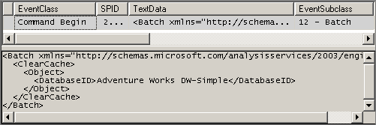
Figure 1
In addition, after clearing the cache, we execute the following MDX query to reload the MDX script (without loading any data in cache).
SELECT {} ON 0
FROM [Adventure Works]
We combined the preceding XMLA statement and MDX query into a single batch file (separated by a GO statement) that we execute by using the ASCMD sample command-prompt utility (you cannot combine these if you execute them by using SQL Server Management Studio). The ASCMD command-line utility sample is available from http://www.codeplex.com/MSFTASProdSamples.

Getting Started with Query Execution Analysis
In this section, we discuss the information revealed in a SQL Server Profiler trace when a number of simple MDX queries are executed against the Adventure Works cube in the Adventure Works DW–Simple database. We focus on reading the information reported in the trace and interpreting what it tells us about the inner workings for the formula and storage engines.

Cache Matching, Filtering, and Prefetching
In this section, we analyze the following queries by using SQL Server Profiler and reviewing the profiler traces.
Note For these queries, we are interested in understanding patterns that will hold true for larger datasets and for which the time differences will be larger as the datasets get larger. The times for these particular datasets will be quite short.

Query 1a
SELECT [Measures].[Internet Sales Amount] ON 0
,[Date].[Calendar].[Calendar Quarter].Members ON 1
FROM [Adventure Works]

Query 1b
SELECT [Measures].[Internet Sales Amount] ON 0
,[Date].[Calendar].[Calendar Quarter].&[2003]&[1] :[Date].[Calendar].[Calendar Quarter].&[2004]&[2] ON 1
FROM [Adventure Works]

Query 2a
SELECT [Measures].[Internet Sales Amount] ON 0
,[Date].[Calendar].[Calendar Quarter].&[2003]&[1] :[Date].[Calendar].[Calendar Quarter].&[2003]&[2] ON 1
FROM [Adventure Works]

Query 2b
SELECT [Measures].[Internet Sales Amount] ON 0
,[Date].[Calendar].[Calendar Quarter].&[2003]&[4] :[Date].[Calendar].[Calendar Quarter].&[2004]&[1] ON 1
FROM [Adventure Works]

Cold Cache Execution of Query 1a
When Query 1a is executed against the Adventure Works DW-Simple database with cold cache (and preloading the MDX script), Figure 2 shows the events that appear in the SQL Server Profiler trace.
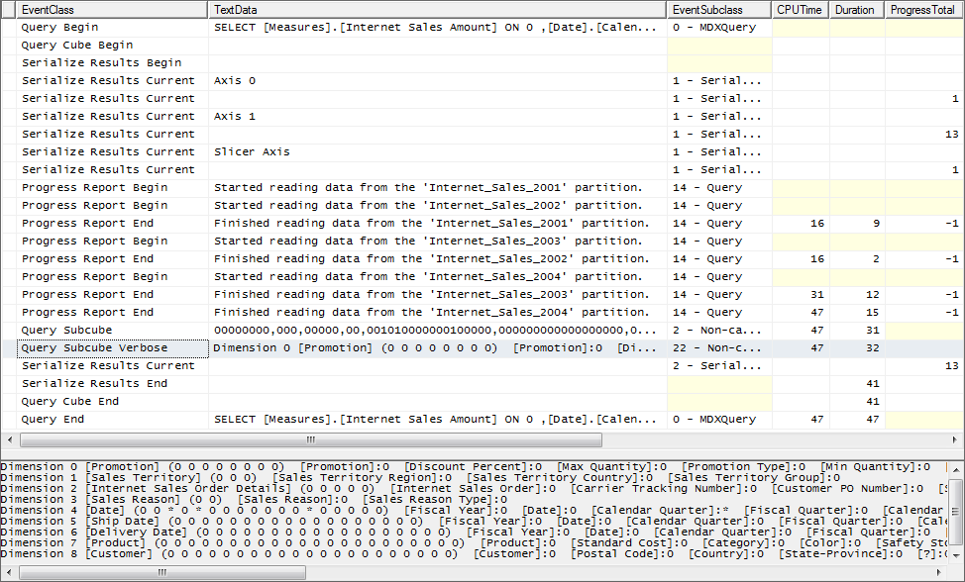
Figure 2
When reviewing the events in this trace, notice that the entire query took 47 ms to execute the following steps to resolve the query and return results to the client.
- The Query Begin event reports that the Analysis Services command parser successfully parsed the MDX query and the formula engine has begun to execute the query. If a syntax error exists in the MDX query, the Query Begin event does not appear.
Note The Execute MDX Script Begin and Execute MDX Script End events do not report that the MDX script is executed because we preloaded the MDX script as discussed previously. After clearing the cache, these events would otherwise appear.
- The Query Cube Begin event reports that all steps that must be completed prior to the execution of the SELECT statement within the MDX query have finished and that the actual execution of the SELECT statement has begun. In the case of this query, no steps were reported.
- A Serialize Results Begin event reports the beginning of resolving the sets on the axes and several Serialize Results Current events report the serialization of Axis 0, Axis 1, and the Slicer Axis (look in the TextData and EventSubclass columns).
- The Progress Total column for the last Serialize Results Current event for Axis 0 reports that there is only one column on Axis 0.
- The Progress Total column for the last Serialize Results Current events for Axis 1 reports that there are thirteen rows on Axis 1.
- A number of Progress Report Begin and Progress Report End events report that the storage engine, at the request of the formula engine, read data from each of the four partitions in the Internet Sales measure group. These partitions are read in parallel.
- The TextData column for these events reports the partition from which the data is read.
- The CPUTime and Duration columns report the processor resources and time required by the storage engine to retrieve data from each partition (in parallel).
- The ObjectPath column (not shown in Figure 2) reports the file system object for each partition.
- The Query Subcube and Query Subcube Verbose events report the subcube returned by the storage engine to the formula engine.
- The TextData column for the Query Subcube Verbose event reports the attribute members from each dimension attribute in each partition included in the subcube returned from the storage system. In this case, all of the members of the [Calendar Quarter], [Calendar Semester], and [Calendar Year] levels in the [Calendar] user hierarchy in the [Date] dimension, and the [All] member of all other attributes in the [Date] dimension and in each of the other dimensions with a relationship with the [Internet Sales] measure group are retrieved by the formula engine from the storage engine. You can determine this information from either the Query Subcube or the Query Subcube Verbose events, but the latter is much easier to read. The * displayed for selected attribute hierarchies in the [Date] dimension reports that all members are retrieved for these three levels in the [Calendar] user hierarchy.
The EventSubclass column for the Query Subcube Verbose event reports whether the data was retrieved from cache data or non-cache data.
Note If the query had requested the [Calendar Quarter] attribute hierarchy directly rather than as part of the [Calendar] user hierarchy (or if the [Calendar] user hierarchy were not a strong hierarchy), the [Calendar Semester] and [Calendar Year] members would not have been retrieved into cache. By requesting this data via the user hierarchy, more data is cached, increasing the likelihood (depending on query patterns) that subsequent queries can be answered from the measure group cache (more on this later in this article).
- The TextData column for the Query Subcube event reports information about the attributes with granularity for this query by using 1s (ones) in the subcube vector. The 1s in the third, fifth and thirteenth position in the fifth vector for the Query Subcube event indicate that one or more members of the [Calendar Quarter], [Calendar Semester], and [Calendar Year] attribute in [Date] dimension are retrieved. The 1s do not enable you to determine whether one, some or all members of the attribute are retrieved (you need to use the data for the Query Subcube Verbose event to derive this information).
The EventSubclass column for the Query Subcube event also reports whether the data was retrieved from cache data or non-cache data.
- The CPUTime and Duration columns report the processor resources and time required by the formula engine to retrieve the subcube from the storage engine. Since the formula engine is single-threaded, the sum of each Query Subcube event represents the total time the formula engine was waiting for the storage engine to return data.
- A Serialize Results Current event reports the serialization of cells in the result set and a Serialize Results End event reports the completion of the result set.
- The CPUTime and Duration columns report the total processor resources and time required by the formula engine to serialize the axes and the cells in the result set.
- The ProgressTotal column for the last Serialize Results Current event for cells reports that there are thirteen cells in the result set.
- The Query Cube End event reports the end of the execution of the SELECT statement. The CPUTime and Duration columns report the total processor resources and time required by the formula engine to execute the SELECT statement.
- The Query End event reports the end of the execution of the entire query. The CPUTime and Duration columns report the total processor resources and time required by the formula engine to execute the entire MDX query, including the time spent (if any) executing the MDX script.
Notice that the duration of the entire query was 47 ms, of which approximately 70% was spent in the storage engine (the duration for the Query Subcube Verbose / Query End events). The remainder was spent in the formula engine. This calculation illustrates that, if this were a poorly performing query, you should begin trying to improve performance with the storage engine. However, trying to improve 47 ms total query time is probably not worth your time (although it can be improved both by adding aggregations and by warming the cache – more on these techniques later in this article).

Warm Cache Execution of Query 1a
When Query 1a is executed against the Adventure Works DW-Simple database with warm cache, Figure 3 shows the events that appear in the SQL Server Profiler trace.
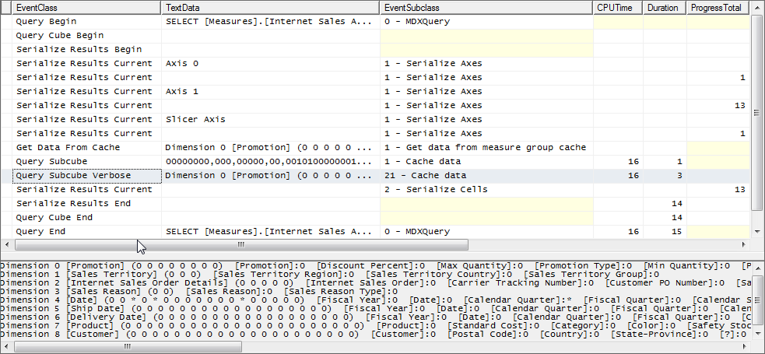
Figure 3
When reviewing the trace events when Query 1a is executed against a warm cache, notice that rather than Progress Reports Begin and Progress Reports End events, a Get Data From Cache event reports that the data requested by the formula engine was retrieved from measure group cache (see the EventSubclass column) rather than from disk. The remaining events are identical. Notice that the duration of the entire query was 16 ms due to the presence of the requested data in cache.
Important Now that all of the members of the [Calendar Quarter], [Calendar Semester], and [Calendar Year] attributes in the [Date] dimension are in the measure group cache for the [Internet Sales] measure group, Analysis Services can perform filtering and aggregation to resolve some subsequent queries from cache rather than disk.
Note The cache contains not just the single measure in the query, but all measures in the measure group at the granularlity of the subcube.

Warm Cache Execution of Query 2a (cache filtering) after Query 1a
Query 2a requests a range between two specific calendar quarters within Calendar Year 2003. When Query 2a is executed against the Adventure Works DW-Simple database with the warm cache from Query 1a, Figure 4 shows the events that appear in the SQL Server Profiler trace.
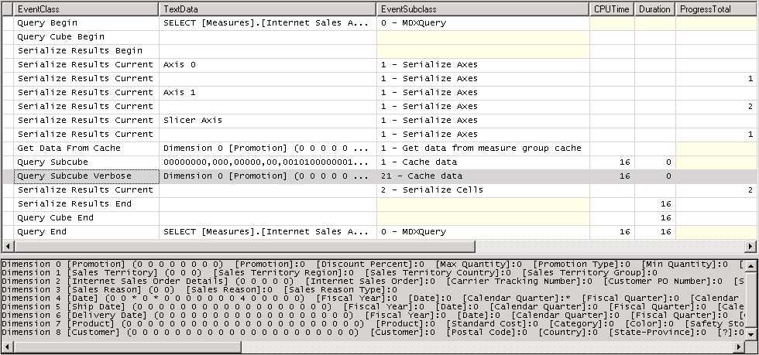
Figure 4
When reviewing the events in this trace, notice that this query is resolved from the existing subcube in the measure group cache (notice the Get Data From Cache event and the EventSubclass column for the Query Subcube and Query Subcube Verbose events). The Query Subcube Verbose event (see Figure 5) reports that the [Calendar Year] attribute member with a data ID of 4 along with all members of the [Calendar Quarter] and [Calendar Semester] attributes that exist with this calendar year are retrieved from cache (see the EventSubclass column) to answer this query. Data ID of 4 corresponds to the [2003] member of the [Calendar Year] attribute. The storage engine is able to cover Query 2a by using the data in its measure group cache because only a subset of the subcube in cache is requested (* * 4 for the requested attributes is covered by * * * in the measure group cache from the results of Query 1a).
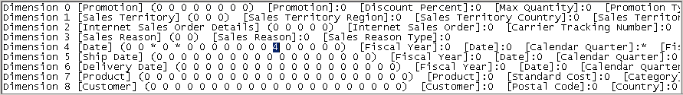
Figure 5
Notice also that the formula engine is retrieving all quarters and semesters in 2003 from the measure group cache into the formula engine cache to answer Query 2b, even though only two quarters are necessary to answer the query. The prefetching behavior of the formula engine is discussed in more detail later in this article.
Important In order to benefit later queries, Analysis Services may request more data than is required to answer an individual query. While this design generally improves overall performance, it may impact the performance of an individual query and can result in an individual query being resolved from disk even though the information necessary to resolve the query is actually in cache.
Note You can use either or both of two connection string parameters to experiment with modifying the prefetching behavior of the formula engine. These two parameters are Disable Prefetch Facts=true and Cache Ratio=1. To use these parameters, you must use a utility such as ASCMD as SQL Server Management Studio does not support modification of connection string parameters. However, in most cases, you do not need to modify connection string parameters other than for testing purposes.

Warm Cache Execution of Query 2b (cache filtering) after Query 1a
Query 2b requests a range between two specific calendar quarters within two different calendar years. When Query 2b is executed against the Adventure Works DW-Simple database with warm cache from Query 1a, Figure 6 shows the events that appear in the SQL Server Profiler trace.
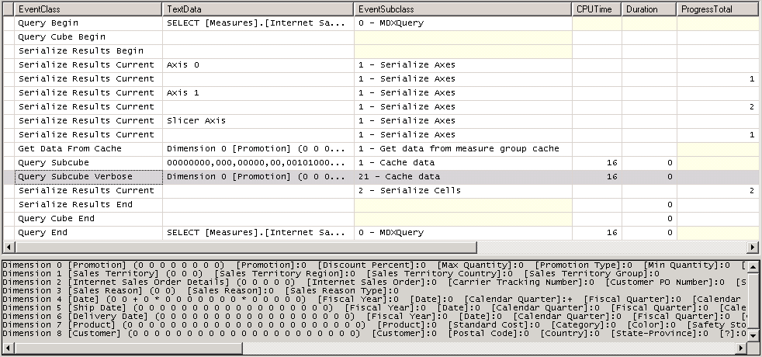
Figure 6
When reviewing the events in this trace, notice that this query is also resolved from the subcube in the measure group cache. The Query Subcube Verbose event (see Figure 7) reports that selected members of the [Calendar Quarter] attribute hierarchy (notice the +) along with all members of the [Calendar Semester] and [Calendar Year] attributes that exist with the calendar quarters requested (notice the *) are retrieved to answer this query. The storage engine is able to cover Query 2b by using the data in its measure group cache because only a subset of the subcube in cache is requested (+ * * for the requested attributes is covered by * * * in the measure group cache from the results of Query 1a).
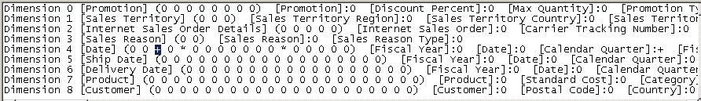
Figure 7

Cold Cache Execution of Query 1b
Query 1b requests a range between two specific calendar quarters within two different calendar years, which are in different partitions. When Query 1b is executed against the Adventure Works DW-Simple database with cold cache (and preloading the MDX script), Figure 8 shows the events that appear in the SQL Server Profiler trace.
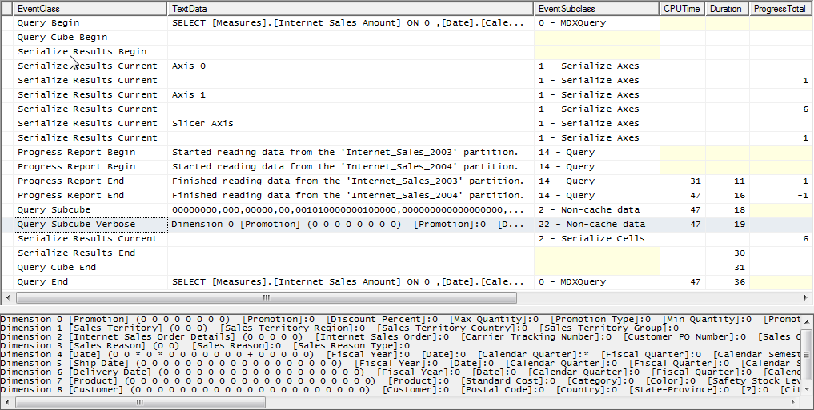
Figure 8
When reviewing the events in this trace, notice that (unlike Query 1a) the Query Subcube Verbose event (see Figure 9) reports that only selected members of the [Calendar Year] attribute (notice the +) along with all members of the [Calendar Quarter] and [Calendar Semester] attributes that exist with those specific attributes are retrieved from disk to answer this query. Only selected members are returned because Query 1a only requested information about a selected range of calendar quarters.
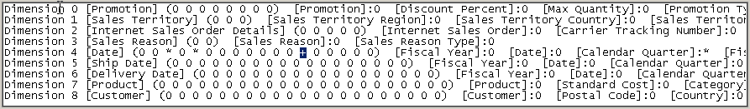
Figure 9

Warm Cache Execution of Query 2a (cache filtering) after Query 1b
Query 2a requests a range of two specific calendar quarters within a single calendar year. When Query 2a is executed against the Adventure Works DW-Simple database with warm cache from Query 1b, Figure 10 shows the events that appear in the SQL Server Profiler trace.
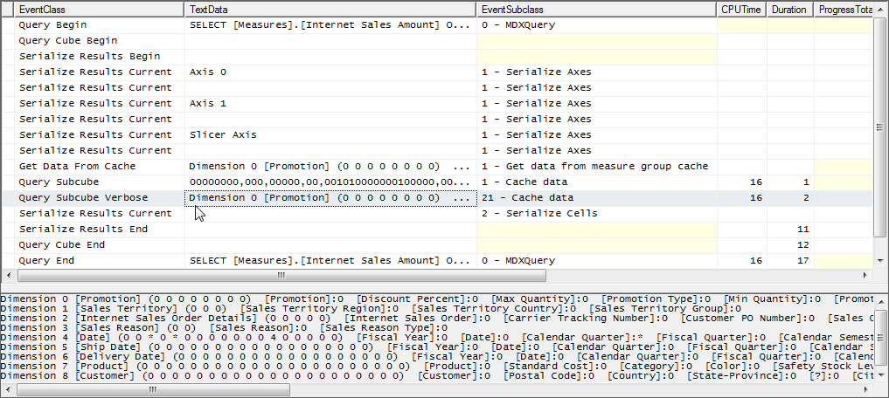
Figure 10
When reviewing the events in this trace, notice that this query is resolved from the existing subcube in the measure group cache. The Query Subcube Verbose event (see Figure 11) reports that the [Calendar Year] attribute member with a data id of 4 along with all members of the [Calendar Quarter] and [Calendar Semester] attributes that exist with the requested calendar years are retrieved to answer this query. The storage engine is able to cover Query 2a by using the data in its measure group cache because only a subset of the subcube in cache is requested (* * 4 for the requested attributes is covered by * * + in the measure group cache from the results of Query 1b).
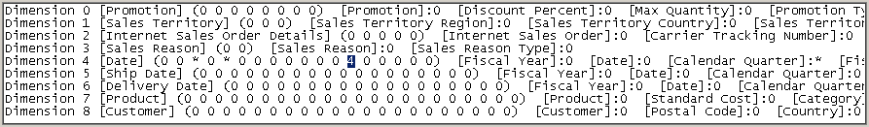
Figure 11

Warm Cache Execution of Query 2b (cache filtering) after Query 1b
Query 2b requests a range of two specific calendar quarters within different calendar years. When Query 2b is executed against the Adventure Works DW-Simple database with the simplified MDX script and warm cache from Query 1b, Figure 12 shows the events that appear in the SQL Server Profiler trace.
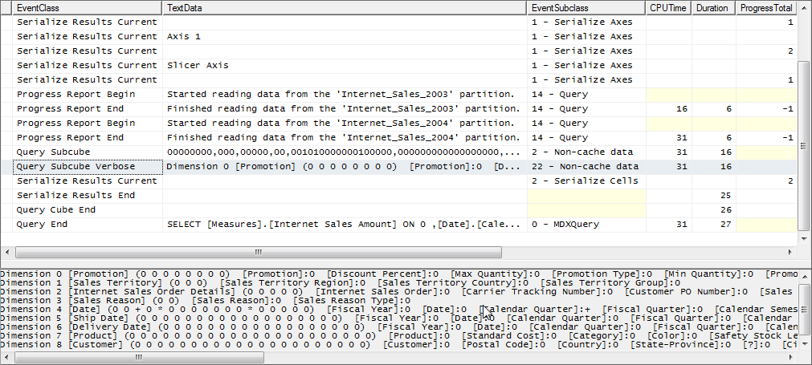
Figure 12
When reviewing the events in this trace, notice that this query is not resolved from the existing subcube in the measure group cache. The Query Subcube Verbose event (see Figure 13) reports that selected members of the [Calendar Quarter] attribute (notice the +) along with all members of the [Calendar Semester] and [Calendar Year] attributes that exist with the requested calendar quarters are retrieved to answer this query. The storage engine is unable to cover Query 2b by using the data in its measure group cache because the subcube requested does not match the subcube in cache. This is because the server code cannot guarantee that the second query can be covered (answered) by the data cache from the first query.
Figure 13
Inside the storage engine’s data cache lookup, each attribute is considered separately, without regard to the set of hierarchies that the attributes belong to, and without regard to the slice members. The second request is for all years (*) and the first subcube has only some years (+). A request for * cannot be guaranteed to be covered by a +.
This behavior is quite interesting. A human would expect the second subcube request to be answered by the first subcube, because a human is smart enough to know the actual years contained in the second data cache are the same present in the + for the first subcube. This behavior occurs because, by default, subcube requests are not normalized (converted to a standard or canonical format). It is possible to have the server internally rewrite the second subcube request to attempt to use the same + for [Calendar Year]. The subcube normalization of slices works by going through each attribute that has a slice, and propagating the set of parents upward through the hierarchy.
Note Unless subcube query requests are normalized, the semantics of each subcube stored into the measure group cache determines the subcubes that can be derived from it. In some cases, due to semantic mismatches, subcubes requested by the formula engine cannot be derived from existing subcubes even though we, as humans, know that the data in cache could be used to cover the newly requested subcube. Enabling subcube normalization may assist in these scenarios. However, since this is a server-wide setting, all queries will be affected. For assistance with enabling subcube normalization, open a case with Microsoft Customer Support Services. Modifying the default subcube normalization behavior of SQL Server 2005 Analysis Services without assistance from Microsoft Customer Support Services is unsupported.

Prefetching and Request Reordering
In this section, we analyze the following query by using SQL Server Profiler and reviewing the profiler traces.
The formula engine uses a number of heuristics when formulating subcube requests from the storage engine to attempt to optimize overall performance. These include fetching data in one subcube request into cache for use by subsequent queries and the ordering of subcube requests for an individual query to optimize the use of cache (by retrieving as much information as necessary to answer a query by using as few noncached subcube query requests as possible). The number and shape of the subcube requests by the formula engine are determined by how far ahead the formula engine can see in the query and the contents of the data in the measure group cache.
Tip As mentioned previously, you can use either or both of two connection string parameters to experiment with modifying the prefetching behavior of the formula engine. These two parameters are Disable Prefetch Facts=True and Cache Ratio=1. To use these parameters, you must use a utility such as ASCMD.exe; SQL Server Management Studio does not support modification of connection string parameters. However, in most cases, you do not need to modify connection string parameters other than for testing purposes.
One strategy for improving a complex query is to first use the Create Cache statement or the WITH CACHE clause to populate the server’s data cache, followed by the query. With this approach it can be valuable when executing the query to disable the heuristics that might cause extra members to be retrieved by adding both of these connection string parameters. The first disables a heuristic for prefetching. The second controls another heuristic for the ratio of requested members to members existing in the dimension. One place we often see these heuristics affect queries is with date hierarchies and PeriodToDate calculations.

Query 3
SELECT Descendants
([Product].[Product Categories].[Category].[Bikes]
, [Product].[Product Categories].[Subcategory]
, SELF_AND_BEFORE) ON 0
, CROSSJOIN
([Measures].[Internet Sales Amount]
,[Date].[Calendar].[Calendar Quarter].&[2003]&[1]
:[Date].[Calendar].[Calendar Quarter].&[2004]&[2])
ON 1
FROM [Adventure Works]
Note In this query, the crossjoin is executed by using the CROSSJOIN () syntax rather than the polymorphic cross join operator (*) syntax as the code in SQL Server 2005 is optimized for the CROSSJOIN syntax and is not optimized for the polymorphic cross join operator (*) syntax.

Cold Cache Execution of Query 3
When Query 3 is executed against the Adventure Works DW-Simple database with cold cache (and preloading the MDX script), Figure 14 shows the events that appear in the SQL Server Profiler trace.
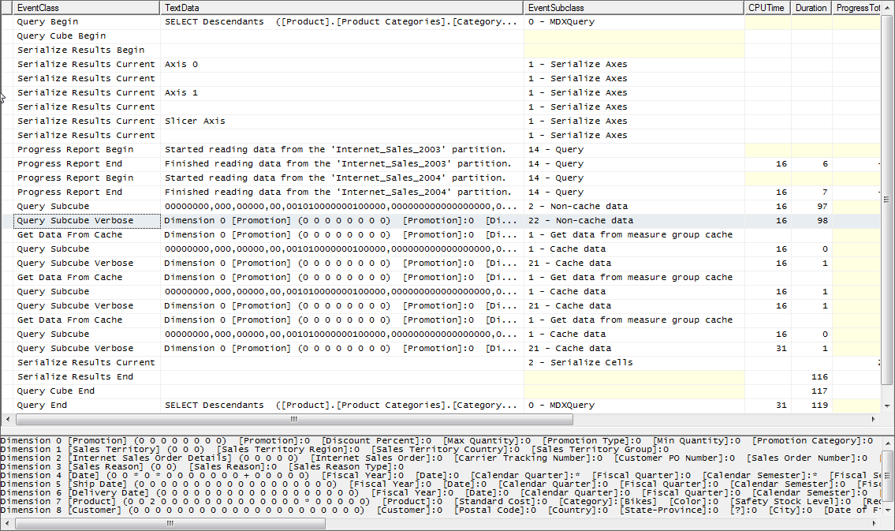
Figure 14
When reviewing the events in this trace, notice that the formula engine requested the subquery from the storage engine with the granularity necessary to resolve the query and retrieved the data requested by the MDX query with only a single request to the disk. When you look carefully at this non-cache data request (looking at the Query Subcube Verbose event), notice that this non-cache data request is the first subcube request and that the request is for the [Bikes] member of the [Product Category] attribute and all members of the [Product Subcategory] attribute that exist with the [Bikes] member. Notice also that four subsequent subcube query requests are all resolved from the measure group cache from the initial non-cache subcube query request.
Important The formula engine generated the necessary subcube request, not in the order in which the cell data appears in the result set, but in the order the formula engine determined to be optimal to minimize the number of requests from disk (maximizing the use of cache for performance reasons).
Warm Cache Execution
When Query 3 is executed against the Adventure Works DW-Simple database when the Analysis Services cache is warm from the previous execution of Query 3, Figure 15 shows the events that appear in the SQL Server Profiler trace.
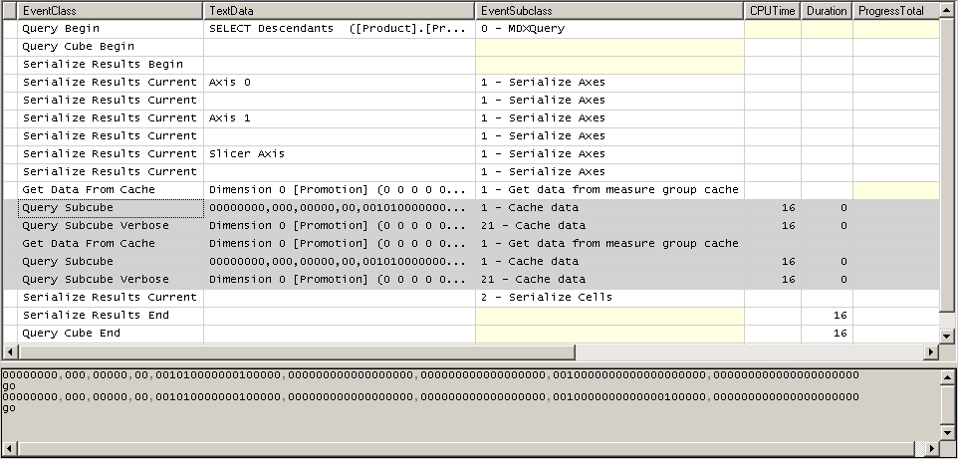
Figure 15
When reviewing the events in this trace, notice that the formula engine requested only two subqueries from the storage engine rather than the four subqueries required when the cache was cold. Both subqueries were resolved from the measure group cache.
- The first subquery is a request for the [Bike] member of the [Product Category] attribute in the [Product] dimension, all members of the [Calendar Quarter] and [Calendar Semester] attributes in the [Date] dimension, selected members of the [Calendar Year] attribute in the [Date] dimension, and the [All] level from all other attributes in all dimensions related to the [Internet Sales] measure group.
- The second subquery is a request for all members of the [Product Subcategory] attribute in the [Product] dimension and for the [Bike] member of the [Product Category] attribute in the [Product] dimension, all members of the [Calendar Quarter] and [Calendar Semester] attributes in the [Date] dimension, selected members of the [Calendar Year] attribute in the [Date] dimension, and the [All] level from all other attributes in all dimensions related to the [Internet Sales] measure group.
Important Performance problems may appear when the formula engine is unable to formulate a small number of non-cache subcube queries (generally five or fewer) to resolve a query (resulting in an excessive number of query subcube requests that are not resolved from cache data). In this case, you generally have two options:
- You can write a more optimal MDX query that assists Analysis Services in formulating a smaller number of query subcube requests that are resolved from non-cache data. For example, in some cases, the use of the Descendants function rather than specifically listing members from different levels can have a similar effect. See Appendix B for a list of optimized MDX language constructs.
- You can also warm the cache to assist Analysis Services by ensuring that the non-optimum (excessive) number of subqueries can be resolved from cache data. This may also reduce the number of subqueries requested by the formula engine. Only in a rare case will the resolution of a large number of subqueries from cache data be the source of performance issues. We discuss solution options for preloading cache later in this document.

Storage Engine Bottlenecks and Solutions
To resolve storage engine bottlenecks that decrease the performance of an individual MDX query, you can either reduce the time the storage engine takes to retrieve the necessary data from disk or take steps to ensure that the necessary data resides in cache before the subquery from the formula engine requests the data.

Reducing Disk I/O
There are three basic techniques that you can use for reducing the time the storage engine takes to retrieve the necessary data from disk to resolve a non-cached subquery request. These are:
- Define aggregations from which the storage engine can either directly or indirectly resolve the data requested by a subquery.
- Define partitions that enable the storage engine to retrieve the data requested by a subquery from a smaller portion of the disk (when the query is requesting a limited range of data that matches your partitioning scheme) and from multiple partitions in parallel.
- Increase the performance of your disk I/O subsystem.
Note For more information about these techniques, see the SQL Server 2005 Analysis Services Performance Guide.

Manually Warming the Cache
To ensure that the necessary data resides in cache before a particular subquery requests the data, you can pre-load selected data into cache. This technique is called warming the cache. You can choose to pre-load the cache immediately before the poorly performing query is submitted for resolution or immediately after processing and before any user queries are submitted. With the first option, you tailor the cache warming to match the individual query. With the second option, you warm the cache in such a way to optimize the broadest set of queries possible (this is an art).
Important Spending an hour to warm the cache to increase the performance of a query from warm cache from several minutes to several seconds may be counterproductive. In most cases, you should attempt to reducing disk I/O before you try warming the cache to improve query performance.
There are a variety of tools that you can use to warm the cache. These tools include:
- Reporting Services reports
- Integration Services packages
- ASCMD batch files
- The Create Cache statement or WITH CACHE clause
This document demonstrates the use of the Create Cache statement in an MDX query that is executed from an ASCMD batch file. For more information on the use of the Create Cache statement, see How to warm up the Analysis Services data cache using Create Cache statement.

Using Partitions and Aggregations
This section looks at the execution of a query from the point of view of optimizing the performance of the storage engine. In particular, we look at the use of partitions and aggregations to improve performance.

Query 4a
SELECT {
[Measures].[Internet Sales Amount]
, [Measures].[Internet Average Sales Amount]
, [Measures].[Internet Ratio to Parent Product]
,[Measures].[Internet Order Count]}
ON 0
, NON EMPTY CROSSJOIN
(Descendants
([Product].[Product Model Categories].[Category].[Bikes]
, [Product].[Product Model Categories].[Subcategory]
, SELF_AND_BEFORE)
, [Date].[Calendar].[Calendar Quarter].members
, Descendants
([Customer].[Customer Geography].[Country].&[Australia]
, [Customer].[Customer Geography].[State-Province]
, SELF_AND_BEFORE)
)
ON 1
FROM [Adventure Works]
WHERE {[Date].[Calendar Year].&[2003]
,[Date].[Calendar Year].&[2004]}

Query 4b
SELECT {
[Measures].[Internet Sales Amount]
, [Measures].[Internet Average Sales Amount]
, [Measures].[Internet Ratio to Parent Product]
,[Measures].[Internet Order Count]}
ON 0
, NON EMPTY CROSSJOIN
(Descendants
([Product].[Product Model Categories].[Category].[Bikes]
, [Product].[Product Model Categories].[Subcategory]
, SELF_AND_BEFORE)
, [Date].[Calendar].[Calendar Quarter].members
, Descendants
([Customer].[Customer Geography].[Country].&[Australia]
, [Customer].[Customer Geography].[State-Province]
, SELF_AND_BEFORE)
)
ON 1
FROM (SELECT
{[Date].[Calendar Year].&[2003]
, [Date].[Calendar Year].&[2004]}
ON 0 FROM [Adventure Works])
These queries request one regular measure, two calculated measures, and one distinct count measure on the column axis. The first query uses a WHERE clause to restrict the members of the [Calendar Year] attribute to the [2003] and [2004] members while the second query uses a subselect to accomplish the same task.
To resolve this query (based solely on the requirements of the column and row axes), we would expect a minimum of two subcube query requests—one to the Internet Sales measure group and one to the Internet Orders measure group (the storage engine queries each the measure group individually). On the row axis, this query is cross-joining the members from two levels in the [Product Category] user hierarchy in the [Product] dimension with all calendar quarters in the [Calendar] user hierarchy in the [Date] dimension and with the members from two levels in the [Customer Geography] user hierarchy in the [Customer] dimension. As we learned previously, we would expect the formula engine to use cache prefetching and request ordering to minimize the number of non-cache subcubes requested from the storage engine and maximize the reusability of data in measure group cache. Looking at this query quickly, we might expect that the formula engine would create a subcube query request for each measure group for the [Bike] member of the [Category] level and all members of the [Subcategory] level in the Product dimension (that exist with the [Bike] member), all members of the [Calendar Quarter] level in the [Date] dimension, and the [Australia] member of the [Country] level, and all members of the [State-Province] level in the Customer dimension (that exist with the [Australia] member).
However, what is the effect of the set in the WHERE clause and how does it change the foregoing discussion? As Mosha Pasumansky explains in his blog (at http://www.sqljunkies.com/WebLog/mosha/search.aspx?q=sp2&p=1), relating attributes are erased by axes (unlike single tuples and subselects). We chose a set for Query 4a particularly to illustrate this effect. For more information on this topic, see http://www.sqlserveranalysisservices.com/OLAPPapers/AttributeRelationships.htm. Because the row axis in this query requests all members of the [Calendar Quarter] level, the limitation on years in the WHERE clause is ignored. We would expect that the subquery will contain an * for [Calendar Quarter] and therefore the storage engine will read data from all four partitions in each of the measure groups requested on the column axis. Let’s see what actually happens.
Important When conducting query performance analysis, it is quite useful to perform a reality check on a query to attempt to understand the minimum number of subqueries required by you (the human) to resolve the query. If the formula engine approaches or equals this number, spending time trying to improve query performance in this way is not productive.
Note Query 4b demonstrates the effect of using a subselect rather than a set in the WHERE clause. Experiment with changing the WHERE clause from a set to a single tuple to understand the difference.
Working with Partitions
In this section, we see how these queries work with the partitioning scheme in the Adventure Works-Simple database.
Cold Cache Execution of Query 4a
Query 4a is executed against the Adventure Works DW-Simple database with cold cache (and preloading the MDX script). When you review the trace, you will notice the following:
- The [Internet Orders] measure group is queried first. You must look in the ObjectPath column to observe this. There are four non-cache data Query Subcube events and three cache data Query Subcube events related to the [Internet Orders] measure group.
Note There are no Progress Reports Begin or Progress Reports End events reported with respect to querying a partition in a distinct count measure group (due to an omission in the product). You need to review the ObjectPath column to determine the Query Subcube, Query Subcube Verbose and Get Data From Cache events that relate to partitions in a distinct count measure group. You cannot determine the number of partitions queried from this information when partitions in a distinct count measure group are queried and no aggregations are available to answer the query request (all four partitions are queried). As discussed later in this document, when queries against a partition in a distinct count measure group are resolved from aggregations, the number of partitions queried is reported by the Get Data From Aggregation event.
- All four partitions in the [Internet Sales] measure group are queried, as reported by the Progress Reports Begin and Progress Reports End events.
- There are two non-cache data Query Subcube events related to the [Internet Sales] measure group, while there are 14 cache data Query Subcube events related to the [Internet Sales] measure group.
- While serializing the axes, one Serialize Results Current event reports (in the ProgressTotal column) that there are four columns on axis 0 and another Serialize Results Current event reports that there are 132 rows on axis 1 for Query 4a.
- Data to populate the cells in the result set are retrieved from flat cache in the formula engine on a cell-by-cell basis. This cell data was placed in cache from the subcube data retrieved by the formula engine from the storage engine from both measure groups as the formula engine executed the query and calculated results.
- After serializing the cells, a Serialize Results Current event reports (in the ProgressTotal column) that there are 528 cells in the result set (4 x 132).
- The duration of the query was 528 ms on this computer. Of this total, 362 ms was spent retrieving data from the storage engine (calculated by adding the time for all Query Subcube events (cache data and non-cache data events).
With Query 4a, approximately 70% of the time (362 ms / 528 ms) is spent in the storage engine. Optimizing the retrieval of information from storage engine for this query is the most effective use of our time. We already know that partitions are being queried unnecessarily—only calendar quarters in Calendar Year 2003 and Calendar Year 2004 are required to resolve the query. Let’s look at what else is happening with the subcube queries to determine if the formula engine is requesting information efficiently through the use of prefetching and request ordering.
Figures 16 – 19 show the non-cache query subcube events that appear in the SQL Server Profiler trace with respect to the [Internet Orders] distinct count measure group.
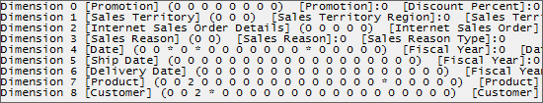
Figure 16
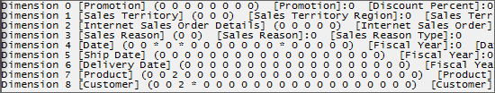
Figure 17
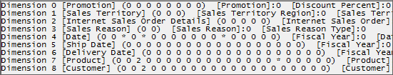
Figure 18
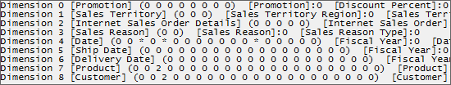
Figure 19
Notice that rather than one or two non-cache data subcube queries, the formula engine consumes the data from four non-cache data (and a number of cache data) subqueries to the [Internet Orders] measure group to answer Query 4a. In SQL Server 2005 Analysis Services, the measure group data cache does not retain distinct keys; therefore, distinct count measure groups cannot have subcubes that are derived from existing data cache entries. Each distinct value requires a separate non-cache data request by the storage engine.
Notice that request ordering was utilized to retrieve data from the Internet Order measure group before data was retrieved from the Internet Sales measure group. The order is important because the [Internet Average Sales Amount] calculated measure in the Internet Sales measure group uses the [Internet Order Count] measure in the Internet Orders measure group in the calculation. By ordering the requests in this order, the [Internet Order Count] measure is in the cache when needed by the latter subcube requests.
Note Systematically reducing the number of measures in this query while re-executing and examining the results in a SQL Server Profiler trace is very helpful in understanding how Analysis Services resolves this query and how efficient the formula engine is in formulating subquery requests.
Figures 20 and 21 show the non-cache query events appear in the SQL Server trace with respect to the [Internet Sales] measure group.
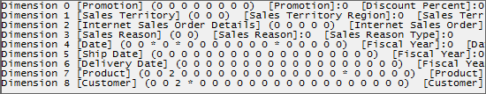
Figure 20
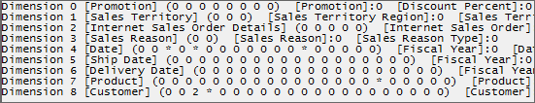
Figure 21
Notice that two non-cache subcube queries were requested by the formula engine from the storage engine to resolve the regular measure and the two calculated measures. By systematically commenting out measures on the column axis in Query 4a, you can quickly determine that the [Internet Sales Amount] regular measure for all of the rows on the row axis is resolved by the first subcube query. In the same manner, you can determine that the second subcube is required by the formula engine to resolve the [Internet Ratio to Parent Product] calculated measure. Looking at the second subcube query, you can determine that all members of the [Subcategory] attribute are requested along with the [All] member of the [Category] attribute. This subcube does not exist in the measure group cache. The [All] member is requested by the formula engine to resolve the [Internet Ratio to Parent Product] calculated measure, which requests the parent member of the current member in the [Product Model Categories] user hierarchy. The [All] level is required for this calculated member when the current member is the [Bike] member in order to calculate the ratio of the [Bike] category member for each quarter, country and state-province to the [All] member. Since this request does not match the data in the measure group cache, a second non-cache subcube query event is reported.
Note If the first request had returned all categories and all subcategories, the second non-cache subquery request would not have been needed (but the first query would have taken more time). If the cache had previously been warmed by such a query, Query 4a could have been resolved from cache.
Warm Cache Execution of Query 4a
Query 4a is executed against the Adventure Works DW-Simple database with warm cache. When you review the trace, the total time required on our test computer was 72 ms—of which only 6 ms relates to the storage engine (1 ms for each cached Query Subcube event). This confirms that the storage engine is a bottleneck for this query when the data is retrieved from cold cache. Notice also that a smaller number of subcube query requests were required to return the data from cache rather than from disk.
Cold Cache Execution of Query 4b
Query 4b is executed against the Adventure Works DW-Simple database with cold cache (and preloading the MDX script). The total time required on our test computer was 444 ms—of which 187 ms relates to the storage engine. This 50% performance improvement in storage engine time over Query 4a occurs because only the 2003 and 2004 partitions are queried, which yields a performance improvement when reading the partitions in the distinct count measure group (which would be significant with a larger dataset).
Important When using subselects in the WHERE clause, the formula engine must calculate visual totals for the All level for the subcube against which the values on the axes are calculated. This can be seen in Queries 4a and 4b—the formula engine has a higher duration for Query 4b than for 4a (166 ms versus 257 ms) due to the extra time required to calculate visual totals.
Working with Aggregations
These times for Query 4a and Query 4b are longer than they need to be (particular with our small cube) when the cache is cold. The storage engine takes this much time to return the requested data primarily because, while the queries are requesting aggregated data, no data has been pre-aggregated. As a result, all data aggregation occurs at query time after all of the detail data is retrieved from disk and before it is returned to the formula engine.
In this section, we look at how Query 4a and Query 4b work with the following custom-designed aggregations in the Adventure Works-Simple database.
- On each partition in the [Internet Orders] measure group, we added a single aggregation on the [Calendar Quarter] attribute in the [Date] dimension, on the [Product Subcategory] attribute in the [Product] dimension, and on the [State-Province] attribute in the [Customer] dimension.
- On each partition in the [Internet Sales] measure group, we added a single aggregation on the [Calendar Quarter] attribute in the [Date] dimension, on the [Product Subcategory] attribute in the [Product] dimension, and on the [State-Province] attribute in the [Customer] dimension.
These attributes were chosen because they are the lowest grain of data requested by Queries 4a and 4b. There is no benefit to adding attributes at a higher grain to the aggregation design, as higher levels can be calculated quickly at query time from lower levels.
Note We added these custom aggregations by using the SP2 Aggregation Manager utility (available on CodePlex at http://www.codeplex.com/MSFTASProdSamples; a community-enhanced version of this utility is available on CodePlex at http://www.codeplex.com/bidshelper). In the Adventure Works DW-Simple cube for this article, you will find that these aggregations already exist in the cube definition, but have no partitions associated with them. By using the SP2 Aggregation Manager utility, you can simply associate all of the partitions in [Internet Orders] measure group and the [Internet Sales] measure group with these existing aggregation designs, and then save the aggregations to the server (save each measure group object). After saving these modifications to the two measure groups to the server, you must process the indexes (the data is not being updated) and clear the cache. Make sure that the IndexBuildThreshold property discussed previously is set to approximately 500 before processing in order to observe the results reported in this article (partitions without indexes are always queried and do not have aggregations). For more information, see SSAS Partition Slicing.
Cold Cache Execution of Query 4b with Aggregations
When Query 4b is executed against the Adventure Works DW-Simple database with cold cache and custom aggregations, the total time required on our test computer was 411 ms—of which 113 ms relates to the storage engine. This improvement is because the requests from the calendar year 2003 and 2004 partitions were answered by using aggregations.
Notice the following events appear in the SQL Server Profiler trace with respect to the use of the newly defined aggregations to resolve subcube query requests against the Internet Orders measure group.
Figure 22 shows the Internet Orders measure group events in the SQL Server Profiler trace after Query 4b is executed.
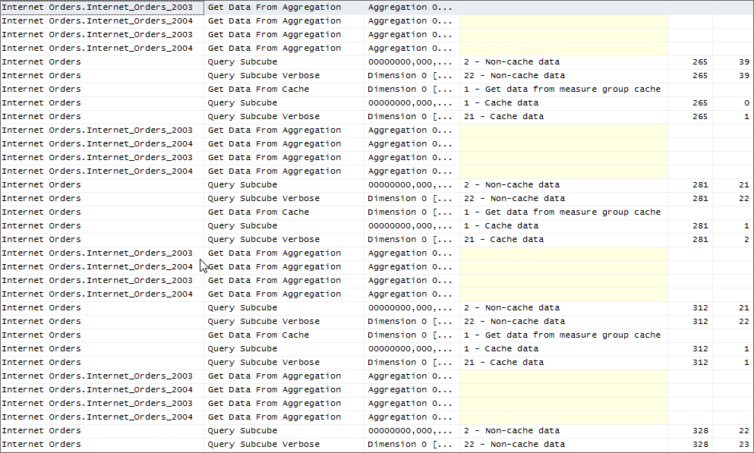
Figure 22
Notice that two Get Data From Aggregation events for the 2003 partition and two Get Data From Aggregation events for the 2004 partition are reported for each non-cached subquery. (This is due to a product omission—only one such event per subquery actually occurred; the data results verify this). The ObjectPath column reports the partition from which each aggregation was read.
Note When a storage engine request for data from a partition is read from an aggregation rather than from the fact level, a Get Data From Aggregation event fires that enables you to determine the partitions in the measure group that were queried (by looking at the data in the ObjectPath column).
Figure 23 shows the Internet Order measure group events in the SQL Server Profiler trace after Query 4b is executed.
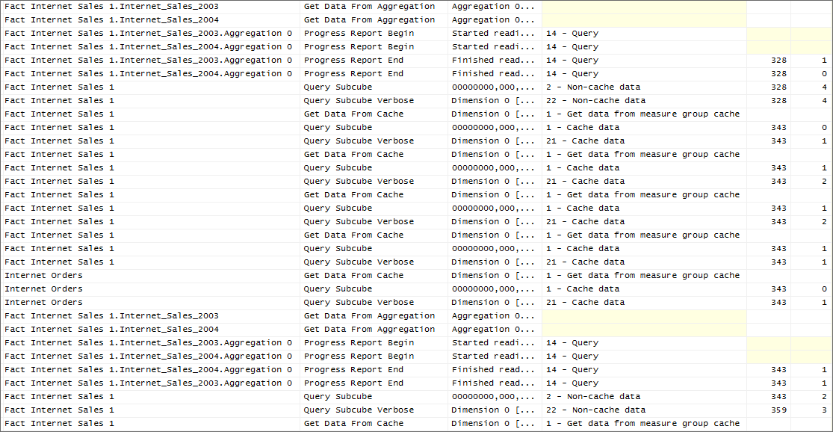
Figure 23
Notice that aggregation 0 is read twice for each partition to answer Query 4b, once for the regular measure and a second time for the calculated measure. The Query Subcube Verbose event shows that different data is returned from this aggregation for the regular measure versus the calculated measure (as previously discussed).

Cold Cache Execution of Query 4a with Aggregations
When Query 4a is executed against the Adventure Works DW-Simple database with the cold cache and custom aggregations, the total time required on our test computer was 526 ms—of which 139 ms relates to the storage engine. The performance penalty incurred by Query 4a caused by reading from excess partitions is reduced because less total data is read when the data is read from aggregations. (The reduction is minor because the 2001 and 2002 partitions in the Adventure Works DW-Simple database are very small.)
Working with Create Cache to Warm the Cache
While the use of aggregations is very effective in improving MDX query performance when data is read from cold cache, the most effective method for improving MDX query performance is to combine the benefits of query optimization, aggregations, and cache warming. As we have seen with Query 4a, prefetching of excess partitions sometimes occurs and Analysis Services cannot always see far enough ahead to cache additional data that may be required for a subsequent calculation. While rewriting your MDX queries is frequently quite helpful (as when Query 4b eliminates the querying of excessive partitions), taking steps to populate the cache before a query arrives can also be a powerful option is some circumstances. For example, if the formula engine generates an excessive number of non-cached subqueries to answer a query, you may not be able to rewrite a query to eliminate excess subqueries. Furthermore, you may encounter situations where different users submit MDX query requests similar to Query 4a or 4b, but each specifying a different time period, country, or product category in their MDX queries. Each of these similar queries must be resolved from disk if the query subcube request cannot be covered by the subcube in cache.
In this section, we will look at how you can issue a single Create Cache statement before queries such as Query 4a or 4b appear in order to warm the cache not only for Queries 4a and 4b but also variations on these queries.

Using the Create Cache Statement or With Cache Clause
You can use the Create Cache statement or the WITH CACHE clause to load data into the cache to improve query performance. In this section, we include a set of Create Cache commands to cover Query 4a and 4b.
Note For more information on the use of the Create Cache statement, see How to warm up the Analysis Services data cache using Create Cache statement
Query 4c
CREATE CACHE FOR [Adventure Works]
AS
(CROSSJOIN
(
{[Measures].[Internet Sales Amount]}
, [Product].[Category].[Category]
, [Product].[Subcategory].[Subcategory]
, [Customer].[Country].[Country]
, [Customer].[State-Province].[State-Province]
, Descendants
({[Date].[Calendar].[Calendar Year].&[2003]
,[Date].[Calendar].[Calendar Year].&[2004]}
,[Date].[Calendar].[Calendar Quarter]
, SELF)
))
GO
CREATE CACHE FOR [Adventure Works]
AS
(CROSSJOIN
(
{[Measures].[Internet Order Count]}
, [Product].[Category].[Category]
, [Product].[Subcategory].[Subcategory]
, [Customer].[Country].[Country]
, [Customer].[State-Province].[State-Province]
, Descendants
({[Date].[Calendar].[Calendar Year].&[2003]
,[Date].[Calendar].[Calendar Year].&[2004]}
,[Date].[Calendar].[Calendar Quarter]
, SELF)
))
GO
CREATE CACHE FOR [Adventure Works]
AS
(CROSSJOIN
(
{[Measures].[Internet Order Count]}
, [Product].[Category].[Category]
, [Customer].[Country].[Country]
, Descendants
({[Date].[Calendar].[Calendar Year].&[2003]
,[Date].[Calendar].[Calendar Year].&[2004]}
,[Date].[Calendar].[Calendar Quarter]
, SELF)
))

GO
CREATE CACHE FOR [Adventure Works]
AS
(CROSSJOIN
(
{[Measures].[Internet Order Count]}
, [Product].[Category].[Category]
, [Customer].[Country].[Country]
, [Customer].[State-Province].[State-Province]
, Descendants
({[Date].[Calendar].[Calendar Year].&[2003]
,[Date].[Calendar].[Calendar Year].&[2004]}
,[Date].[Calendar].[Calendar Quarter]
, SELF)
))
GO
CREATE CACHE FOR [Adventure Works]
AS
(CROSSJOIN
(
{[Measures].[Internet Order Count]}
, [Product].[Category].[Category]
, [Product].[Subcategory].[Subcategory]
, [Customer].[Country].[Country]
, Descendants
({[Date].[Calendar].[Calendar Year].&[2003]
,[Date].[Calendar].[Calendar Year].&[2004]}
,[Date].[Calendar].[Calendar Quarter]
, SELF)
))

Query 4c is written to cover a wide range of query variations on Queries 4a and 4b. Reviewing Query 4c, you can see that it will cover queries against the [Internet Orders] and [Internet Sales] measure groups that request any measures in these measure groups and any or all members of the [Product Category] or [Subcategory] attributes in the [Product] dimension, any or all members of the [State-Province] or [Country] attributes in the [Customer] dimension, and, within Calendar Year 2003 or 2004, any or all members of the [Calendar Quarter] or [Calendar Semester] attributes in the [Date] dimension. Because [Internet Order Count] is a distinct count measure, a separate Create Cache statement is required for each subcube that you intend to cover because, as mentioned previously, distinct count measure groups cannot have subcubes that are derived from existing data cache entries.
The most common syntax approaches for Create Cache are to specify a list of members, to use Descendants, and to specify attributes explicitly.
When using the Descendants function, common choices are to use SELF or SELF_AND_BEFORE. Typically, SELF is preferred because it specifies only the lower level and other subcubes can be derived from it. In the previous examples, each statement results in one subcube request.
By using SELF_AND_BEFORE, all combinations of levels are generated. This might be desirable, but it could easily lead to many, many subcube requests. For example for two dimensions with three and four levels, the number of subcube combinations is 3*4 = 12. Also, as the result of a product omission, subcube requests are ordered backwards from smallest to biggest. Because of this ordering, each is obtained as a non-cache data subcube request rather than being derived from the previous subcube queries. One customer has used this approach to bring most of the cube into the data cache registry. It took them a long time to create but provided great improvement to subsequent query times.
Attributes can be specified explicitly. Although each hierarchy can be included only once on an axis, attributes can be specified many times by using the attribute hierarchy syntax. Note that a common mistake is to accidentally specify the hierarchy instead of the attribute. An example would be to specify [Product].[Category] rather than [Product].[Category].[Category]. This does not generate an error message nor does it give the desired effect of including the attribute.
Note that for a hierarchy used in a query, you should include all the levels above the ones needed, so that the subcube will include an * for each attribute and can therefore cover later queries. And example would be to specify [Product].[Category].[Category] as well as [Product].[Subcategory].[Subcategory]. One might expect that this could be done automatically, but during query time the pattern matching for covering subcubes does not consider hierarchies.
When you execute Query 4c and review the trace, you will notice a number of non-cached query events against the [Internet Orders] and the [Internet Sales] measure groups, all of which are resolved from the aggregations defined previously in the [Internet Orders] and [Internet Sales] measure groups. On our test computer, these Create Cache statements require 248 ms to complete. While Query 4c requires some additional time to execute, this is a one-time performance penalty incurred to support a range of queries patterned around Queries 4a and 4b. To write a Create Cache statement simply to support Queries 4a and 4b, restrict the attributes covered by the Create Cache statement and reduce the one-time performance penalty.
Note that this sample cube is very small; the query duration is not the primary consideration, but rather that Create Cache provides a way to minimize the number of subcube requests. A common practice is to use a small database during development to investigate and solve performance problems. One can expect that when run on the large production database, the durations increase and the number of subcube requests remain constant. In other words, the specification for what data to get remains the same, but the number of rows will increase. The cases where Create Cache has been valuable had initial query times in tens or hundreds of seconds.
Execution of Query 4b after Query 4c
Query 4c is executed against the Adventure Works DW-Simple database with the cold cache, and then Query 4b is executed. In the trace, you will notice that only cached data subcube query events appear. The time required on our test computer to execute this query was 148 ms, of which only 16 ms relates to the storage engine because only cached data subcube query events appear.
Execution of Query 4a after Query 4c
Query 4c is executed against the Adventure Works DW-Simple database cold cache, and then Query 4a is executed. When you review the trace, you will notice that non-cache data subcube query events appear. The reason for this, as discussed previously, is that Analysis Services prefetches all members of the [Calendar Year] attribute (*) in the [Date] dimension (data for only two calendar years is in the data cache). While we could modify the Create Cache statement to cover all years, the best thing to do, in this scenario, is to prevent Analysis Services from prefetching. Since we are partitioning by years (to reduce the portion of the disk touched by queries for only recent information), we do not want Analysis Services to retrieve data across all partitions when data from all partitions is not required to answer the query.
Note We have observed problems with prefetching in a number of scenarios with large or complex cubes and extensive partitioning that we could not solve by rewriting the MDX query. For example, we have seen the PeriodsToDate function cause prefetching across partition boundaries and cause performance problems that we could resolve only by disabling prefetching.
Execution of Query 4a after Query 4c with Cache Prefetching Disabled
SQL Server 2005 Analysis Services with Service Pack 2 now supports connection string parameters that enable you to disable cache prefetching on a per connection basis. However, since SQL Server Management Studio does not support the use of connection string parameters, we use the ASCMD sample utility to execute queries from the command line.
Important Disabling prefetching for all queries may cause performance problems unless the queries are covered by the data already in cache. In most scenarios, it is not recommended to disable prefetching.
The following ASCMD batch file is used to execute Query 4a and disable cache prefetching.
ascmd -S localhost -xc "Disable Prefetch Facts=true;Cache Ratio=1" -d "Adventure Works DW-Simple" -i Query4a.mdx -o result.xml -v cube="[Adventure Works]"
With cache prefetching disabled and the cache warmed by using the Create Cache statement in Query 4c, no non-cache query subcube events appear in the trace. The duration for Query 4a is 78 ms (of which 32 ms is spent in the storage engine). This duration is the fastest query response time for the result requested by the variations of Query 4 discussed in this article.
Important For Query 4c to cover Query 4a, you must execute Query 4c with cache prefetching enabled and Query 4a with cache prefetching disabled. If you execute Query 4c with cache prefetching disabled, you will see + rather than * for various attributes in various query subcube events. These will not cover the + and data IDs for various attributes formulated by the formula engine for Query 4a when cache prefetching is disabled.

Formula Engine Bottlenecks and Solutions
To resolve formula engine bottlenecks that decrease the performance of an individual MDX query, you must determine the source of the formula engine bottleneck. Unfortunately, neither SQL Server Profiler nor System Monitor provide much guidance in isolating the source of the bottleneck and pointing you to possible resolutions. Common sources of formula engine bottlenecks are one or more of the following:
- MDX queries that are resolved by using cell-by-cell evaluation rather than by using block-oriented evaluation. In SQL Server 2005 Analysis Services, block-oriented evaluation by MDX language constructs has only been partially implemented. For a list of MDX language constructs that have been optimized to support block-oriented evaluation, see Appendix B. Prime examples of queries that can benefit from block-oriented evaluation are queries that use Case or IIF for dynamic evaluation (run-time checks) or queries that contain calculated members that do not use non-empty behavior.
- Custom member formulas and unary operators for custom rollup calculations
- Analysis Services stored procedures
- MDX functions based on Microsoft Visual Basic® (such as StrToSet, StrToMember, etc)
- Linked objects (linked dimensions and measure groups)
- LookupCube function
Determining the precise source of a formula engine bottleneck is more of an art than a science for most because the Analysis Services query analysis tools provide little insight. In some cases, you can verify that cell-by-cell evaluation is occurring and attempt to rewrite the MDX query to take advantage of block-oriented evaluation. In many cases, you may be able to use MDX Script scope assignments when defining calculations over a selected portion of a cube (or use the CREATE CELL CALCULATION statement in an MDX query itself) to facilitate block-oriented evaluation. In many cases, your best technique may be to simplify the query until you have isolated the real source of the performance bottleneck. In other cases, you may have to use specialized tools to assist you. For example, you may need to use a tool such as KernRate to figure out why a stored procedure is consuming too much time.
Note For more information about writing efficient MDX, including the use of SCOPE, see the SQL Server 2005 Analysis Services Performance Guide.

Ranking Over Sets
In this section, we look at the execution of two different MDX queries that return the ranking of employees based on their sales. While each of these queries returns the same result, the speed with which they perform is dramatically different. We will look at the information returned in a SQL Server Profiler trace as well as by System Monitor counters to attempt to understand the performance differences between these two queries.

Query 5a
WITH MEMBER [Measures].[Employee Rank] AS
RANK
([Employee].[Employee].CurrentMember ,ORDER
([Employee].[Employee].[Employee].MEMBERS
,[Measures].[Reseller Sales Amount]
, BDESC)
)
SELECT [Measures].[Employee Rank] ON 0
,[Employee].[Employee].[Employee].MEMBERS on 1
FROM [Adventure Works]

Query 5b
WITH SET OrderedEmployees AS
ORDER
([Employee].[Employee].[Employee].members
, [Measures].[Reseller Sales Amount]
, BDESC)
MEMBER [Measures].[Employee Rank] AS
RANK
([Employee].[Employee].CurrentMember
, OrderedEmployees)
SELECT [Measures].[Employee Rank] ON 0
,[Employee].[Employee].[Employee].MEMBERS ON 1
from [Adventure Works]

Cold Cache Execution of Query 5a
When Query 5a is executed against the Adventure Works DW-Simple database with cold cache, Figure 24 shows the events that appear in the SQL Server Profiler trace. If you watch the execution of this query in SQL Server Profiler, it will appear to hang for awhile on the second Query Subcube Verbose event while calculations are performed. During this time, no events appear in the trace.

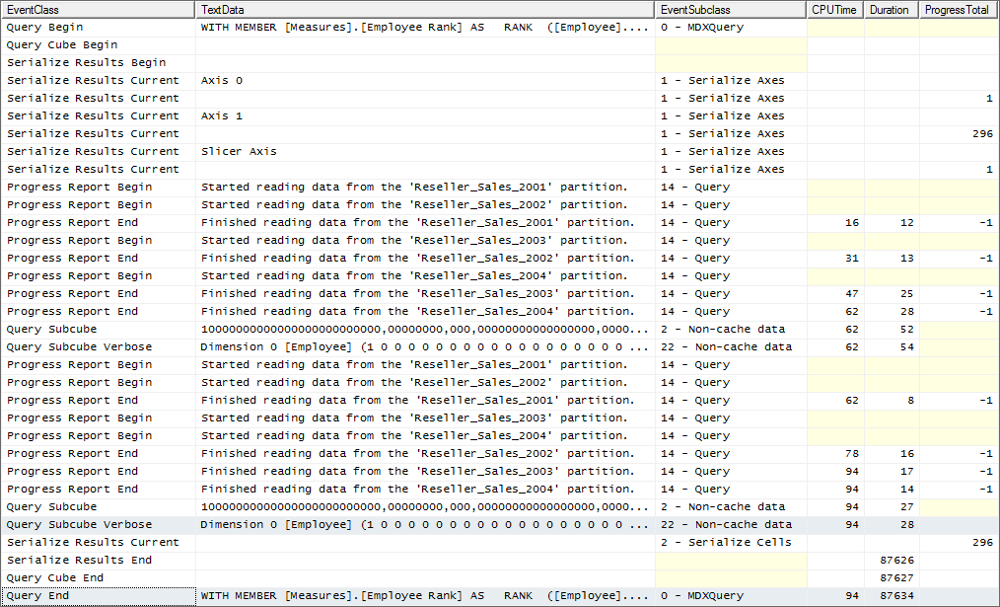
Figure 24
Notice that of the total query duration of 87,634 ms, less than one-tenth of 1% of the time is spent in the storage engine. While you could add appropriate aggregations for this query, spending time in the storage engine for this query would accomplish little. (You can verify this by re-running Query 5a against warm cache.) For this query, spend time improving the performance of the formula engine. However, there is no information in the trace to assist you. Looking at selected counters in System Monitor provides you with a little more information—namely that many cell-by-cell calculations are being performed (almost 3 million). The MSAS 2005:MDX\Total cells calculated counter (see Figure 25) shows the number of cells that were computed by performing cell-by-cell evaluation.
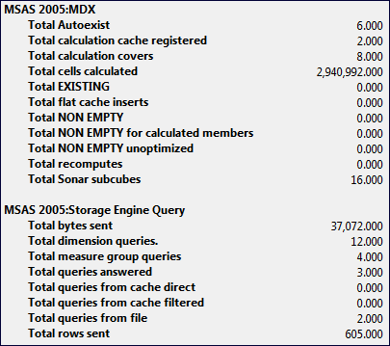
Figure 25
Query 5a calculates rank over order, requiring that the ordering of all employees be done for every single cell where the calculated member is evaluated.
Cold Cache Execution of Query 5b
When Query 5b is executed against the Adventure Works DW-Simple database with cold cache, Figure 25 shows the events that appear in the SQL Server Profiler trace. If you watch the execution of this query in SQL Server Profiler, it will execute far faster.
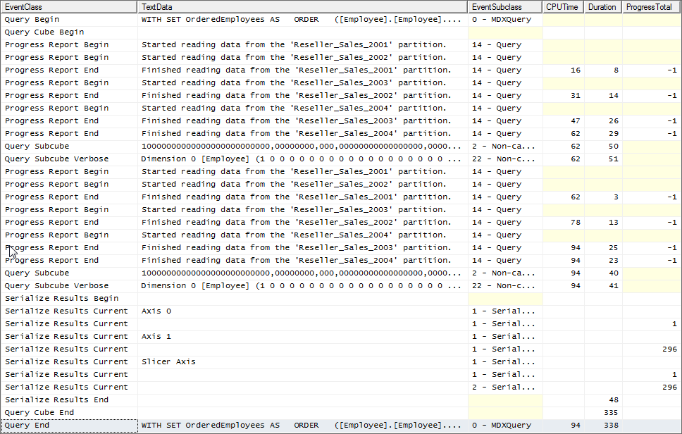
Figure 26
Notice that the total query duration is reduced to 338 ms, of which 27% is spent in the storage engine (quite an improvement). If this query is resolved from cache, the total query duration is reduced to 189 ms. This tells us that spending a little time with aggregations might still have some marginal benefit.
Looking at selected counters in System Monitor for Query 5b, as in Figure 27, provides you with some information about why Query 5b is faster than Query 5a—only 5,510 calculations are being performed (rather than almost 3 million).
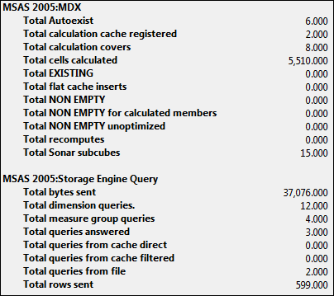
Figure 27
Query 5b is much faster because Query 5b sorts only once and then performs a linear scan of a hash index to look up each employee’s position in the sorted list. The formula engine did not choose this execution plan for Query 5a because it has no way to know that the set over which the Order function is evaluated is static rather than dynamic. When you know that a set is static, defining a set as we have done with Query 5b can dramatically improve performance within the formula engine.
Note Mosha Pasumansky has a blog entry that explains in detail why Query 5a is slow and why Query 5b is much faster. To read this blog for a full explanation, go to http://www.sqljunkies.com/WebLog/mosha/search.aspx?q=rank&p=1.

Case, IIF, and Non_Empty_Behavior
This section looks at the execution of four different MDX queries that return budget variance from actual. While each of these queries returns the same result, the speed with which they perform is dramatically different. These queries demonstrate some performance differences between the Case and the IIF statements in SQL Server 2005 Analysis Services, and the benefit of using the Non_Empty_Behavior clause with calculations to avoid performing expensive calculations at query time over sparse cube space. The use of IIF and the Non_Empty_Behavior clause enable the formula engine to perform block-oriented evaluation to resolve the query rapidly.

Query 6a
/* Case statement w/o NEB */
WITH MEMBER [Scenario].[Scenario].[Budget Variance Case] AS
Case
When IsEmpty
(([Measures].[Amount], [Scenario].[Scenario].[Budget]))
Then NULL
When [Account].[Accounts].CurrentMember.Properties("Account Type")
Or [Account].[Accounts].CurrentMember.Properties("Account Type")
= "Liabilities"
Then ([Measures].[Amount],[Scenario].[Scenario].[Budget])
- ([Measures].[Amount],[Scenario].[Scenario].[Actual])
Else ([Measures].[Amount],[Scenario].[Scenario].[Actual])
- ([Measures].[Amount],[Scenario].[Scenario].[Budget])
End
,Format_String = "Currency"
MEMBER Measures.PerfTest AS
SUM ([Date].[Date].[Date]
* [Department].[Department].[Department]
* [Organization].[Organization].[Organization]
, Measures.Amount)
SELECT [Scenario].[Scenario].[Budget Variance Case] ON 0
,[Account].[Accounts].[Conferences] ON 1
FROM [Adventure Works] WHERE Measures.PerfTest

Query 6b
/* Replace Case statement with IIF - w/o NEB */
WITH MEMBER [Scenario].[Scenario].[Budget Variance IIF] AS
IIF(
IsEmpty(([Measures].[Amount],[Scenario].[Scenario].[Budget]))
, NULL
, IIF(
[Account].[Accounts].CurrentMember.Properties("Account Type")
= "Expenditures"
Or [Account].[Accounts].CurrentMember.Properties("Account Type")
= "Liabilities"
,([Measures].[Amount],[Scenario].[Scenario].[Budget])
- ([Measures].[Amount],[Scenario].[Scenario].[Actual])
,([Measures].[Amount],[Scenario].[Scenario].[Actual])
- ([Measures].[Amount],[Scenario].[Scenario].[Budget])
)
)
, FORMAT_STRING = "Currency"
MEMBER Measures.PerfTest AS
SUM(
[Date].[Date].[Date]
* [Department].[Department].[Department]
* [Organization].[Organization].[Organization]
, Measures.Amount)
SELECT [Scenario].[Scenario].[Budget Variance IIF] ON 0
,[Account].[Accounts].[Conferences] ON 1
FROM [Adventure Works] WHERE Measures.PerfTest

Query 6c
/* Case statement with NEB */
WITH MEMBER [Scenario].[Scenario].[Budget Variance Case] AS
Case
When IsEmpty
(([Measures].[Amount], [Scenario].[Scenario].[Budget]))
Then NULL
When [Account].[Accounts].CurrentMember.Properties("Account Type")
= "Expenditures"
Or [Account].[Accounts].CurrentMember.Properties("Account Type")
= "Liabilities"
Then ([Measures].[Amount],[Scenario].[Scenario].[Budget])
- ([Measures].[Amount],[Scenario].[Scenario].[Actual])
Else ([Measures].[Amount],[Scenario].[Scenario].[Actual])
- ([Measures].[Amount],[Scenario].[Scenario].[Budget])
End
,Format_String = "Currency"
,Non_Empty_Behavior = ( [Measures].[Amount],[Scenario].[Scenario].[Budget] )
MEMBER Measures.PerfTest AS
SUM ([Date].[Date].[Date]
* [Department].[Department].[Department]
* [Organization].[Organization].[Organization]
, Measures.Amount)
SELECT [Scenario].[Scenario].[Budget Variance Case] ON 0
,[Account].[Accounts].[Conferences] ON 1
FROM [Adventure Works] WHERE Measures.PerfTest

Query 6d
/* Replace Case statement with IIF and w/NEB */
WITH MEMBER [Scenario].[Scenario].[Budget Variance IIF] AS
IIF(
IsEmpty(([Measures].[Amount],[Scenario].[Scenario].[Budget]))
, NULL
, IIF(
[Account].[Accounts].CurrentMember.Properties("Account Type")
= "Expenditures"
Or [Account].[Accounts].CurrentMember.Properties
("Account Type")
= "Liabilities"
,([Measures].[Amount],[Scenario].[Scenario].[Budget])
- ([Measures].[Amount],[Scenario].[Scenario].[Actual])
,([Measures].[Amount],[Scenario].[Scenario].[Actual])
- ([Measures].[Amount],[Scenario].[Scenario].[Budget])
)
)
, FORMAT_STRING = "Currency"
,Non_Empty_Behavior = ( [Measures].[Amount],[Scenario].[Scenario].[Budget] )
MEMBER Measures.PerfTest AS
SUM(
[Date].[Date].[Date]
* [Department].[Department].[Department]
* [Organization].[Organization].[Organization]
, Measures.Amount)
SELECT [Scenario].[Scenario].[Budget Variance IIF] ON 0
,[Account].[Accounts].[Conferences] ON 1
FROM [Adventure Works] WHERE Measures.PerfTest

Cold Cache Execution of Query 6a
When Query 6a is executed against the Adventure Works DW-Simple database with cold cache, Figure 28 shows the events that appear in the SQL Server Profiler trace.
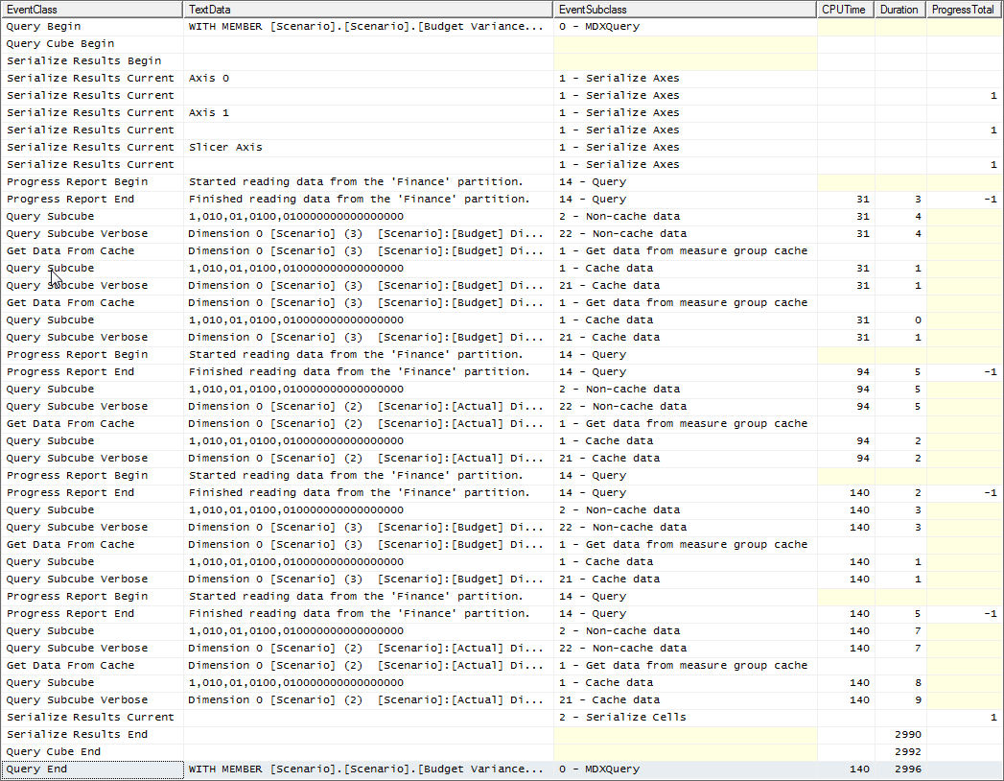
Figure 28
Notice that of the total query duration of 2,996 ms, approximately 1% of the time is spent in the storage engine. While you could add appropriate aggregations for this query, spending time in the storage engine for this query would accomplish little. (You can verify this by re-running Query 6a against warm cache.) For this query, spend time improving the performance of the formula engine. However, there is no information in the trace to assist you. Looking at selected counters in System Monitor provides you with a little more information—namely that many cell-by-cell calculations are being performed (approximately 114,000-see Figure 29).
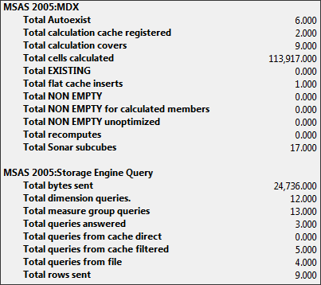
Figure 29
Query 6a is slow because the formula engine is resolving the query by using cell-by-cell evaluation. However, neither SQL Server Profiler nor System Monitor provides assistance in explaining why cell-by-cell evaluation is being performed.
Cold Cache Execution of Query 6b
When Query 6b is executed against the Adventure Works DW-Simple database with cold cache, Figure 30 shows the events that appear in the SQL Server Profiler trace. The only difference between Query 6a and Query 6b is the replacement in Query 6b of Case with IIF.
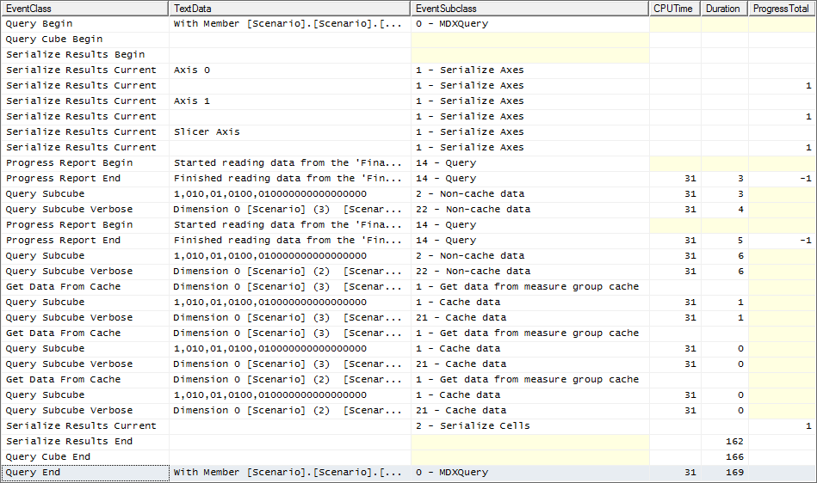
Figure 30
Notice that Query 6b performs dramatically better than Query 6a. This is because, in SQL Server 2005 Analysis Services, the IIF statement supports block-oriented evaluation and the Case statement does not.
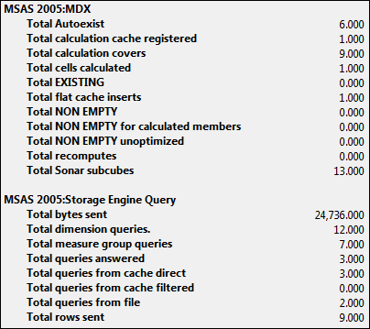
Figure 31
Notice in the previous figure that the MSAS 2005:MDX\Total cells calculated counter reports that only one cell is calculated. This single calculation is for the single cell defined by the query before SUM unrolls the crossjoin set. The remaining calculations required to return the result set are calculated by using block-oriented evaluation. You cannot detect block-oriented evaluation by using either SQL Server Profiler or System Monitor.
Note While there are some other minor differences revealed in System Monitor between Query 6a and Query 6b, they do not help you understand why query is fast and the other is slow.
Cold Cache Execution of Query 6c
When Query 6c is executed against the Adventure Works DW-Simple database with cold cache, Figure 32 shows the events that appear in the SQL Server Profiler trace. The only difference between Query 6a and Query 6c is the use of the Non_Empty_Behavior clause in the WITH MEMBER calculation.
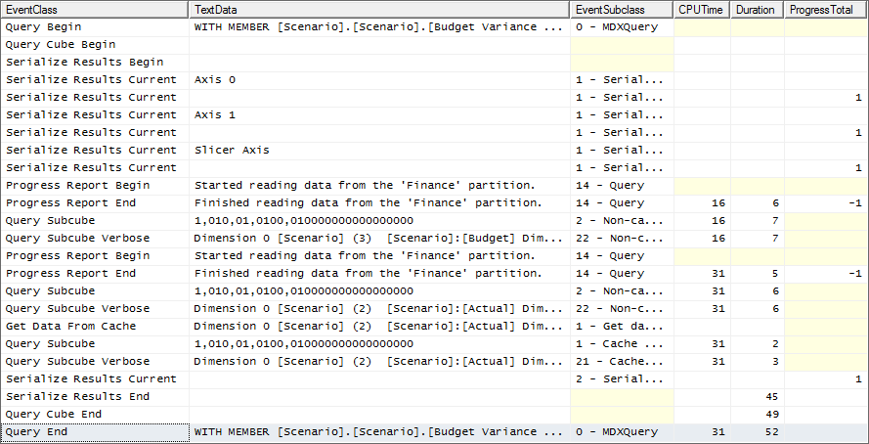
Figure 32
Notice that Query 6c is even faster than Query 6b, even though cell-by-cell evaluation is occurring, as you can confirm with System Monitor by looking at the counters shown in the following figure.
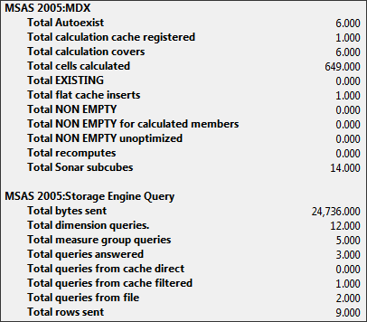
Figure 33
Notice that 649 cells were calculated on a cell-by-cell basis. So, why is Query 6c faster? It is faster because the vast majority of the cells within the scope of the calculation in the query are null and no calculations occur over cells that are null because we added the Non_Empty_Behavior clause. This argument enables the formula engine to skip calculations on all cells that are null for the specified physical measure and only perform the calculation on 649 cells.
Cold Cache Execution of Query 6d
Query 6d is executed against the Adventure Works DW-Simple database with cold cache. The only difference between Query 6c and Query 6d is the replacement of Case with IIF, and the only difference between Query 6b and Query 6d is the addition of the Non-Empty_Behavior argument to the WITH MEMBER clause. The following figure shows the trace.
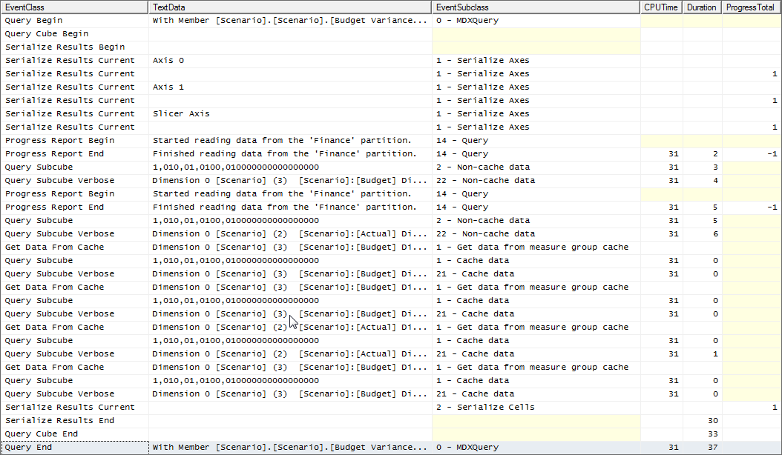
Figure 34
Notice that Query 6d is the fastest of these four queries as shown by the counters in the following figure.
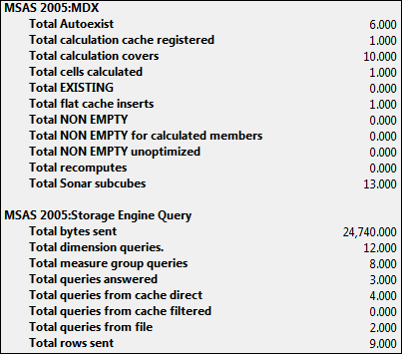
Figure 35
Notice that Query 6d is resolved by using block-oriented evaluation for the 649 cells that are not null for the specified measure in the Non_Empty_Behavior clause.
Note Mosha Pasumansky has a blog entry that explains in detail the differences between these queries and what is happening behind the scenes with these queries. To read this blog for a full explanation, go to http://www.sqljunkies.com/WebLog/mosha/search.aspx?q=variance&p=1.

Conclusion
To resolve MDX performance problems with an individual MDX query, you must first determine if the query is always slow or intermittently slow. For intermittent performance problems, look for resource contention. For a query that consistently performs poorly, determine where the performance bottlenecks are occurring within SQL Server 2005 Analysis Services.
If the storage engine is a bottleneck, determine if partitioning might help, if aggregations are being hit, and if the cache is being used efficiently. Where appropriate, partition each measure group to align to query patterns, define selected aggregations, and determine the best way to optimize the use of cache. Rewrite your MDX queries if that is an option or consider warming the cache.
If the formula engine is a bottleneck, use good troubleshooting techniques to reduce the complexity of a poorly performing query to isolate the portion at the heart of the performance problem. Read everything you can on how to write efficient MDX and enable Analysis Services to enable the formula engine to use block-oriented evaluation whenever possible. Also, you may need to learn how to use specialized tools other than SQL Server Profiler and System Monitor to try to isolate the source of certain types of problems.

Appendix A

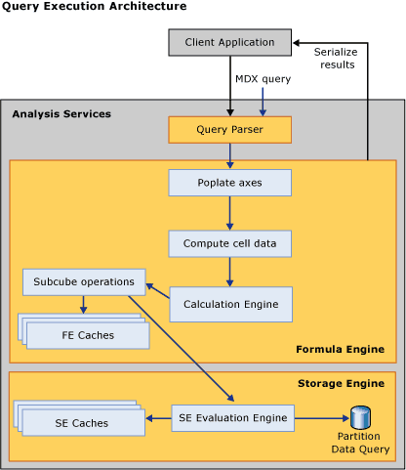

Appendix B
The following list contains the core MDX language constructs that support optimized block-oriented evaluation in SQL Server 2005 Service Pack 2. In general, if an MDX calculation is slow, rewriting it in a way that makes use of only the operators and functions listed here will likely improve performance.

- Arithmetic operators: *, /, +, -
- Static member references
- Static tuple references
- Distributive parent-child unary operators (+, -, ~, numeric weights)
- Semiadditive measures
- Sum/Min/Max/Aggregate (static set expression, …). For instance, Sum(Level.Members) or Sum({CA, WA})
- Sum/Min/Max/Aggregate (set, …), where the set uses a combination of PeriodsToDate, YTD/QTD/MTD, Crossjoin, Cousin, CurrentMember, range (":" operator) and static member and set expressions (this includes the previous construct as a particular case). More detailed explanations about optimizations around Sum (PeriodsToDate or range) can be found at: http://www.sqljunkies.com/WebLog/mosha/archive/2006/11/17/rsum_performance.aspx
- Measures.CurrentMember
- IIF (condition, expression, NULL) in which only "expression" needs to satisfy the other "block-evaluation mode" constraints. For a more detailed explanation about optimizations around IIF (condition, expression, NULL), see http://www.sqljunkies.com/WebLog/mosha/archive/2007/01/28/iif_performance.aspx
- IsEmpty
- Relational operators (<, >, <=, etc.)
- NULL
- Constant scalars

Appendix C
The following list contains the VBA functions in SQL Server 2005 Service Pack 2 that are implemented natively.

- CStr
- CDate
- Int
- CInt
- CLng
- Now
- IsArray
- IsError
- Abs
- Round
- InStr
- Left
- Len
- Mid
- Right

